Undertaking a private autism assessment
There are several organisations which offer private assessments of autism. This guidance documents describes the ways in which you can find a diagnostic assessment provider.
Undertaking a private diagnostic assessment costs money. You may be able to reclaim up to £500 of the cost of the assessment from the University. Details of how to do this, and a link to the application form, can be found on our website.

How to find a diagnostic service using the National Autistic Society Directory
- Go to: https://www.autism.org.uk/directory
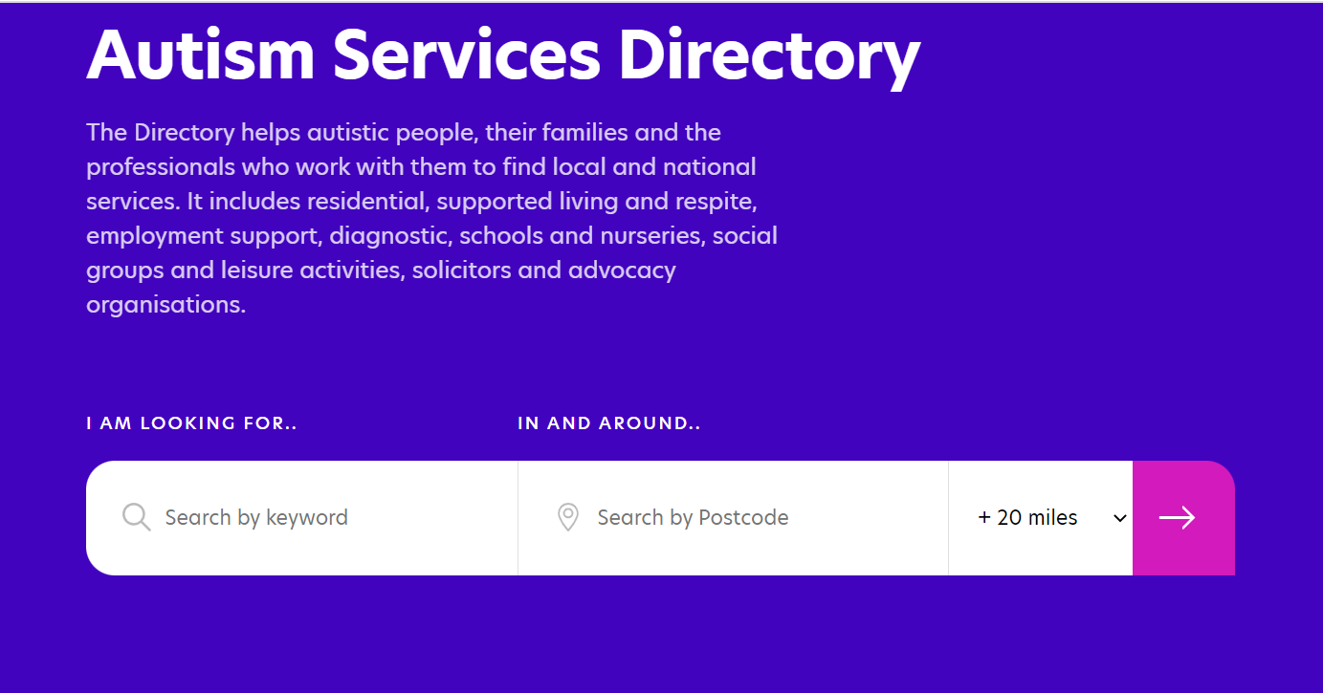
- Type the word ‘diagnosis’ into the Keyword search field. Type your postcode into the Postcode field and adjust the number of miles as required. Then press the pink arrow.
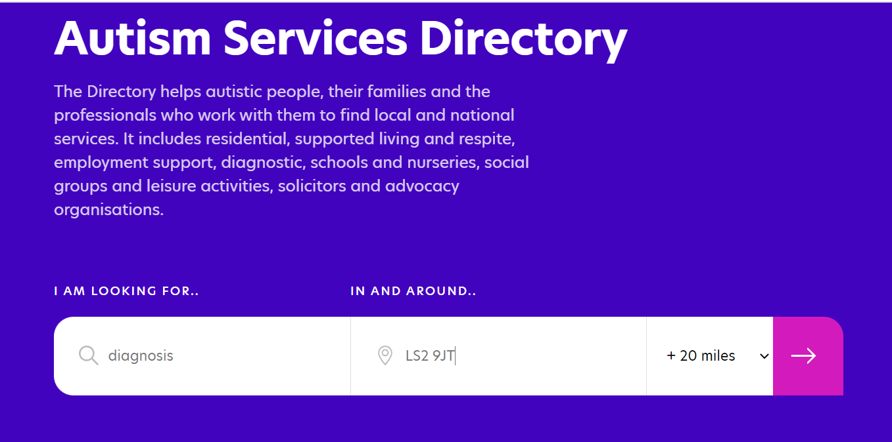
- The search will return lots of results that are not specific to diagnosis. You now need to add some filters, as follows.

- Go to the Aimed At filter and select Adult. Go to the Service Types filter and select Assessment and Diagnosis

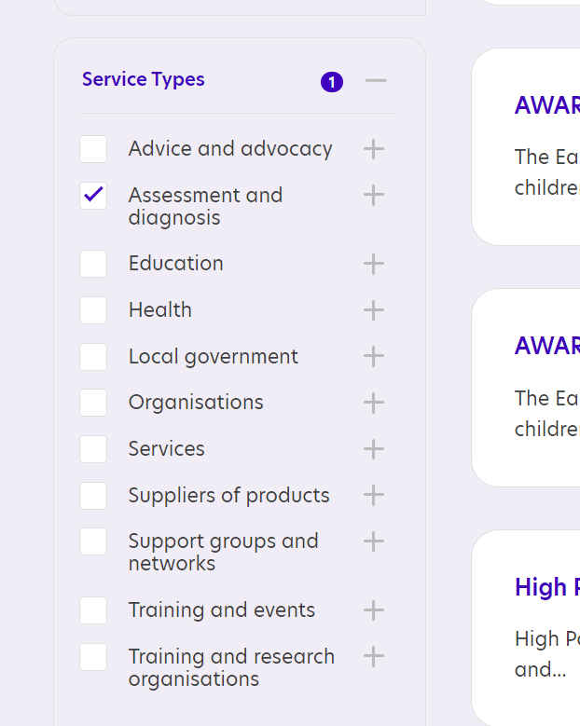
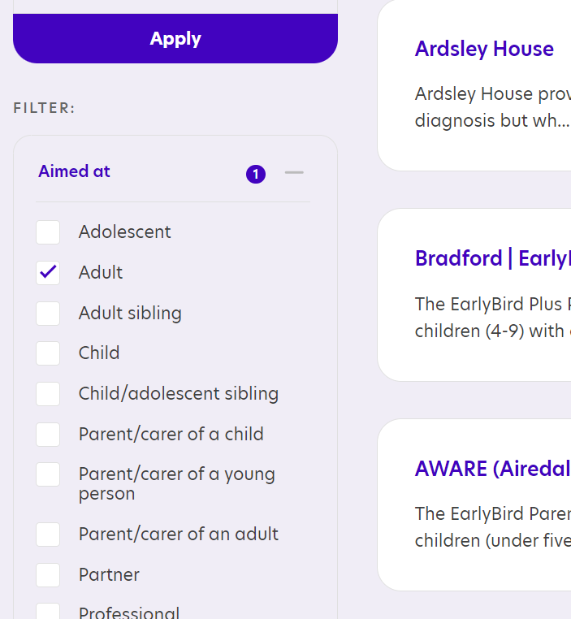
- Click the purple Apply button to run the search

- If you do not get many results, you can broaden the search by changing the distance you are willing to travel for an assessment or searching in a different area.

National providers of adult autism assessments
There are several organisations which offer private assessments of autism. You can find the details of these organisations by entering the term ‘Private adult autism assessment UK’ into a search engine.
Below are some questions you might like to pose to any organisation before booking an assessment with them.

Seeking a private autism assessment: questions to ask
- Who will carry out the assessment? An adult diagnosis of autism can only be formally confirmed by a registered Psychiatrist or a Clinical Psychologist. Some providers also involve Speech & Language Therapists or Occupational Therapists (a multi-disciplinary team), and some use specialist nurses to undertake some of the information gathering, before making a decision on whether a psychiatrist or psychologist should complete the assessment.
- Does the provider focus primarily on children, or do they have good experience of assessing adults? You may wish to find someone who is experienced in assessing adults. You could ask how many adult assessments they have done or ask how many years of experience their diagnosticians have in assessing adults.
- Which diagnostic tool does the provider use? The common tools are ADOS and DISCO – some people find DISCO is a better tool for assessing adults as it takes a broader, more holistic view of the individual and is based on discussion rather than undertaking tasks, which is more appropriate for adults.
- How much developmental history does the provider require, and in what format? Some providers request that a parent or close relative who knew the person being assessed when they were very young (before the age of 5) is present at the assessment. Others capture information via a Relative’s Questionnaire, and some will assess without requiring parental involvement.
- Does the provider issue a full report after the assessment, or simply a letter confirming the outcome? Although assessments which include a report can be more expensive, the report itself is often extremely helpful.
- What format does the assessment take? Is it over one session, or more? How long do sessions usually last? A DISCO assessment takes as long as required – perhaps 4-5 hours, whereas an ADOS assessment is usually quicker. If it’s a long assessment, will there be an opportunity for a break?
- How autism-friendly does the provider seem to be? Have they thought about the sensory environment of the assessment room (e.g. flexible lighting, minimal distractions, comfortable surroundings, as few people as possible present)? Do they communicate effectively and flexibly?
- Does the provider offer any post-diagnostic support included in the cost of assessment? Some providers offer a one-off meeting to discuss the diagnosis and signpost to other support

