Step-by-step guide for uploading your video to Media Site

If you follow this guide, you should find it straight forward to upload your video to the panel for shortlisting. However, if you experience any issues, contact the IT helpdesk who will be able to advise you.

Applications open:
Monday 11th March 2019 at 1pm (13:00 hours)

Closing date for receipt of video submissions:
Monday 8th April 2019 at 4pm (16:00 hours)

Please note – videos received after this date and time will not be accepted.

How to upload a media file via Mediasite

To upload video into My Mediasite, please watch this video and/or follow the following instructions:

- Go to My Mediasite

- Once you have logged in, select ‘Add Media’

- Then click ‘I want to upload a file from my computer’

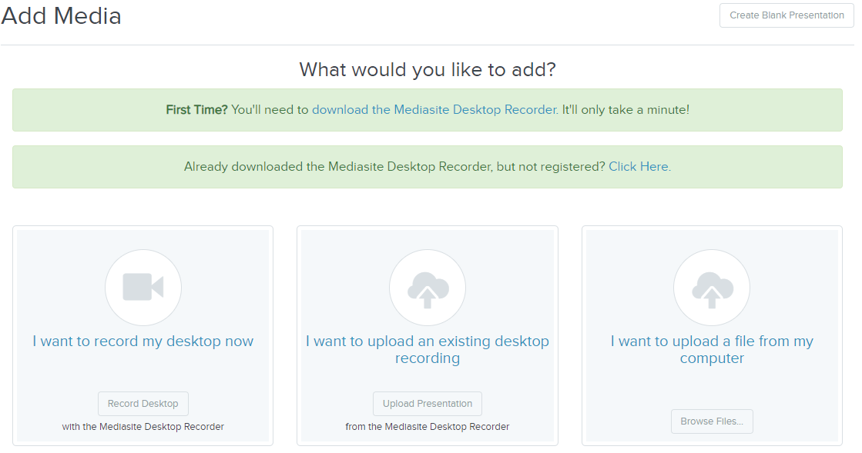

- You now need to name your video upload a name and description as prompted. You can also choose where to upload the media to under 'publish to' but in most cases this can remain as 'Drafts'.

You must use the following naming convention for your video submission as follows:

First Name Family Name Student ID (For example: Joe Bloggs 300400500)
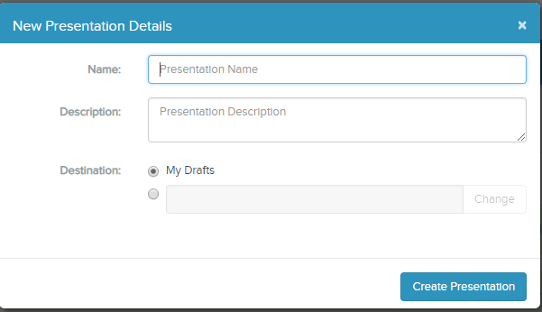

The media file will be uploaded. You can check the progress of the upload by looking at the blue bar.

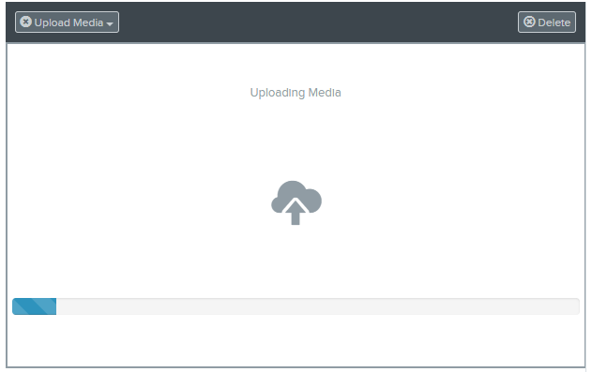

Once the upload is complete, you will receive a notification in the bottom right hand corner of your screen. Please note, do not close your browser window until the upload is complete and you receive the notification:

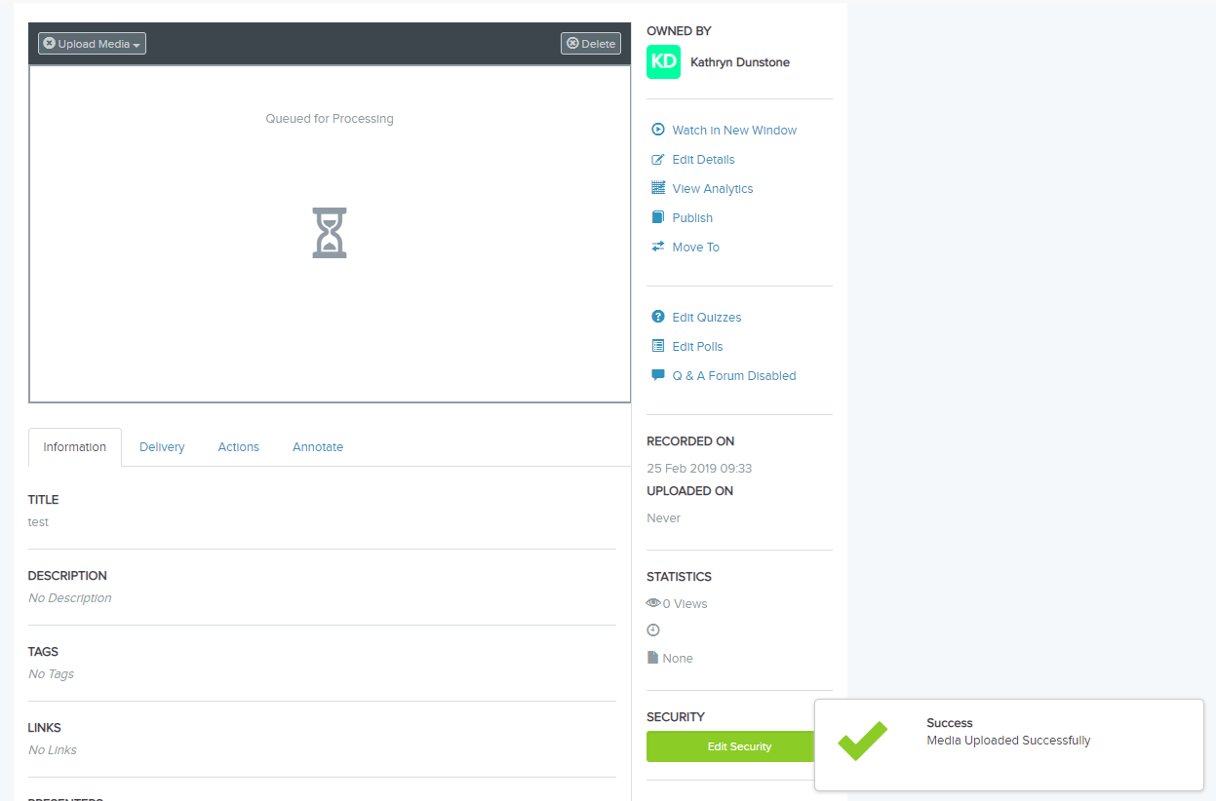

- The upload will be processed and you will receive an e-mail once the upload is ready to view.

- Uploading and processing of any recording can take up to 8 hours.

Note - Plan ahead! Make sure that you submit your video at least 8 hours before the closing date and time. If you submit just before the closing time, and the upload takes several hours, your video will not be accepted, as it has been received after the closing date and time.

When planning to submit your video application, you should check that you are able to upload without any issues if you are not on campus. You may also wish to factor in additional time to first share your video with a friend to ensure that they can view the video, that picture and sound quality is clear. You may also want to allow yourself time for contacting the IT helpdesk if you have any issues uploading your video.

Sharing your recording

- Locate the recording you wish to share by logging into My Mediasite directly or by logging into the VLE and selecting the ‘My Media’ tab.

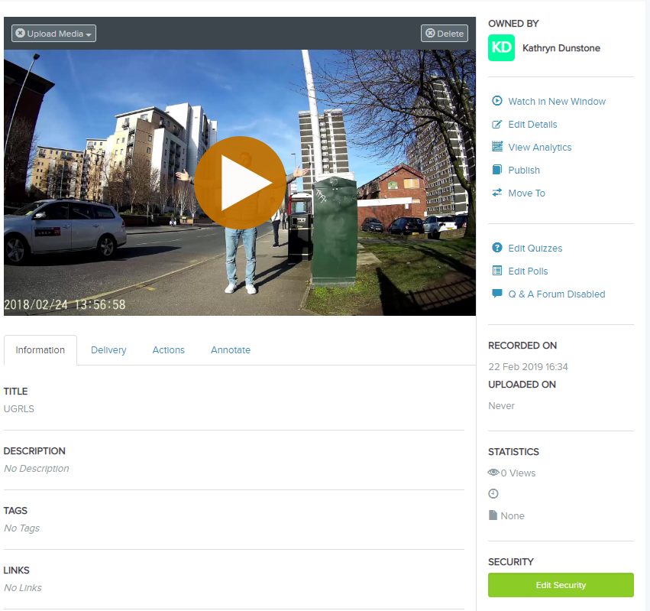

- Click ‘Edit Security’ button on the right hand side. In the “Add people or groups” box, type sesoutsa and select it to add it to your list. If the box is not visible, untick “Inherit permissions from parent folder”.
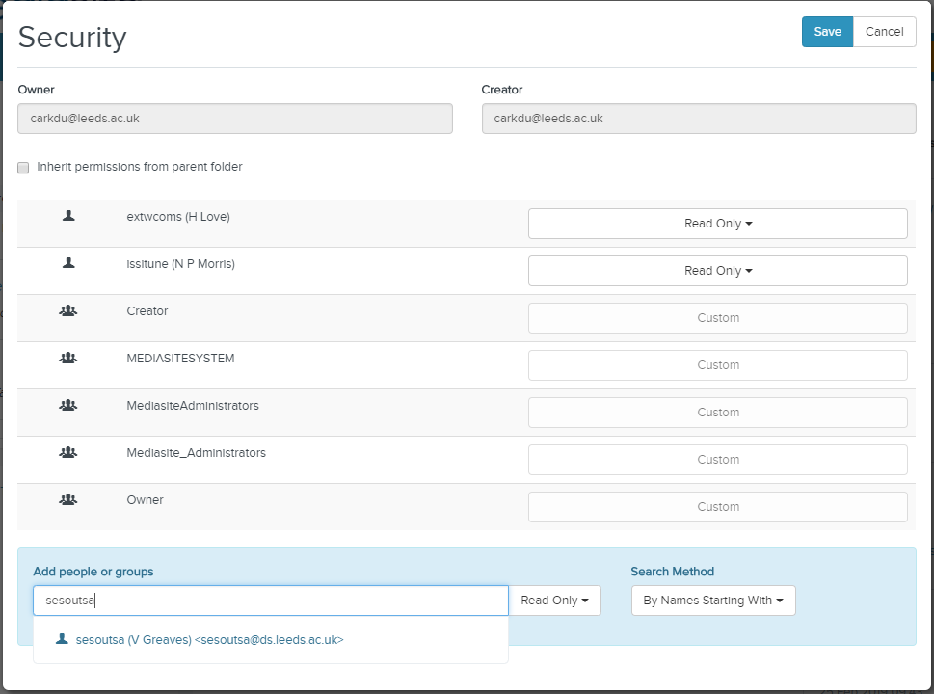

- Once you’ve selected sesoutsa it gets added to the list – you can then pick ‘viewer’ from the drop-down.

- Click ‘Save’.

- Select the ‘Edit Details’ tab, change the visibility to ‘Viewable’ and click ‘Save’:

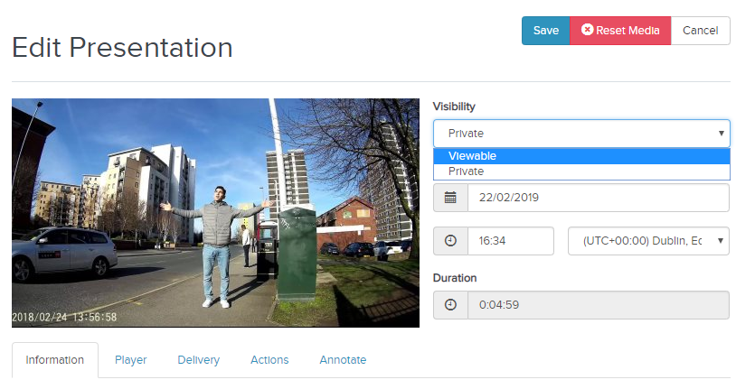

- Your recording is now available publicly. From the Share presentation button you can copy and paste the share link:
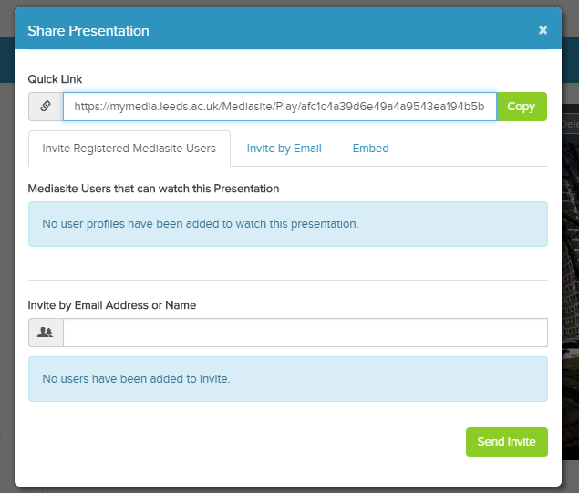

- Submit this link when submitting your application through MyCareer.

Please note - When we view your video we will check the date and time of when your video was uploaded. If the date and time of the upload is after the closing date and time, your application will not be taken forward.

If you have any questions on the video process, please contact IT helpdesk. If you have any questions about the programme or your application, please contact Outgoing Study Abroad (outgoingstudyabroad@leeds.ac.uk).

Good luck!

