Spending Facility

- Chemistry West Block – to the left of the main entrance
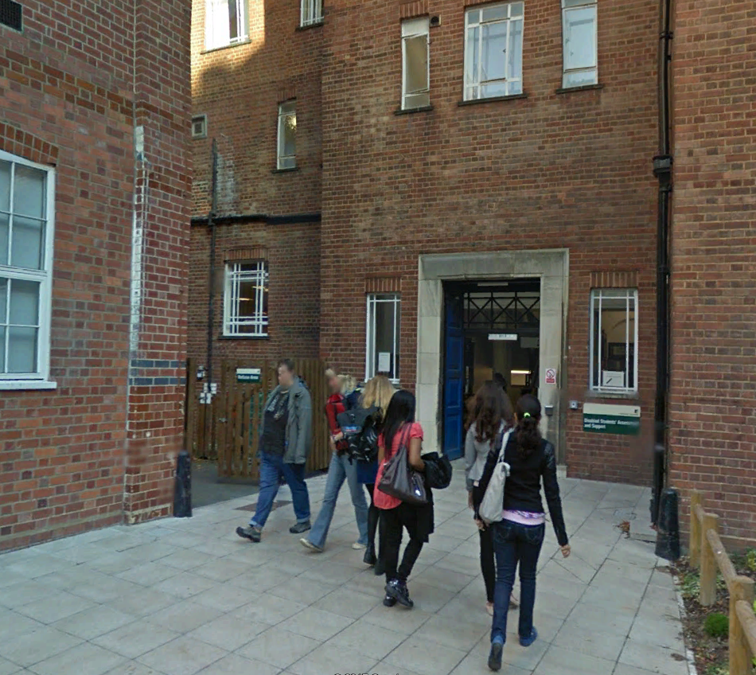
- 18 Beech Grove Terrace – behind the building
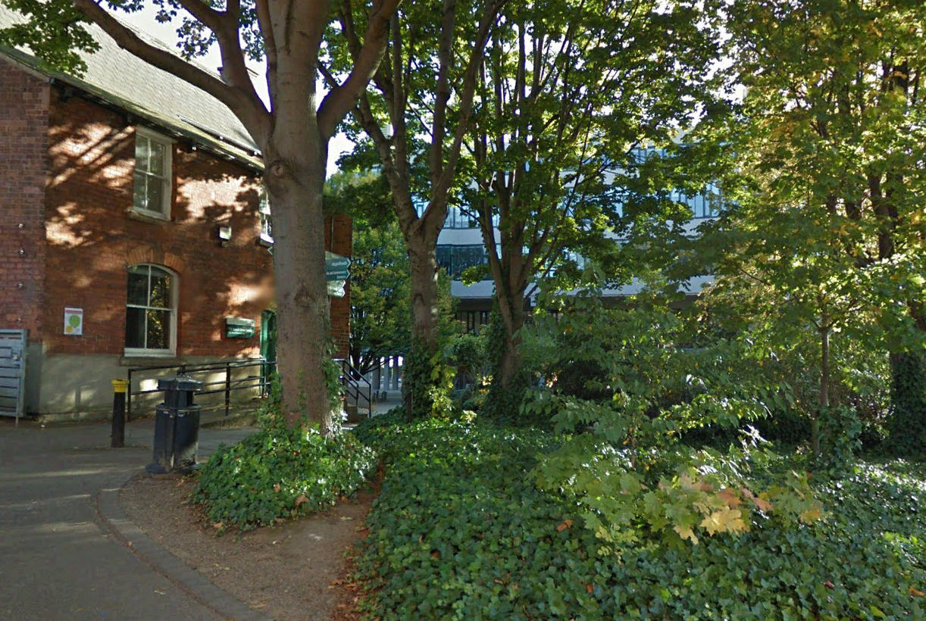

- Clarendon Place – grassed area where Clarendon Place meets Clobbery Street
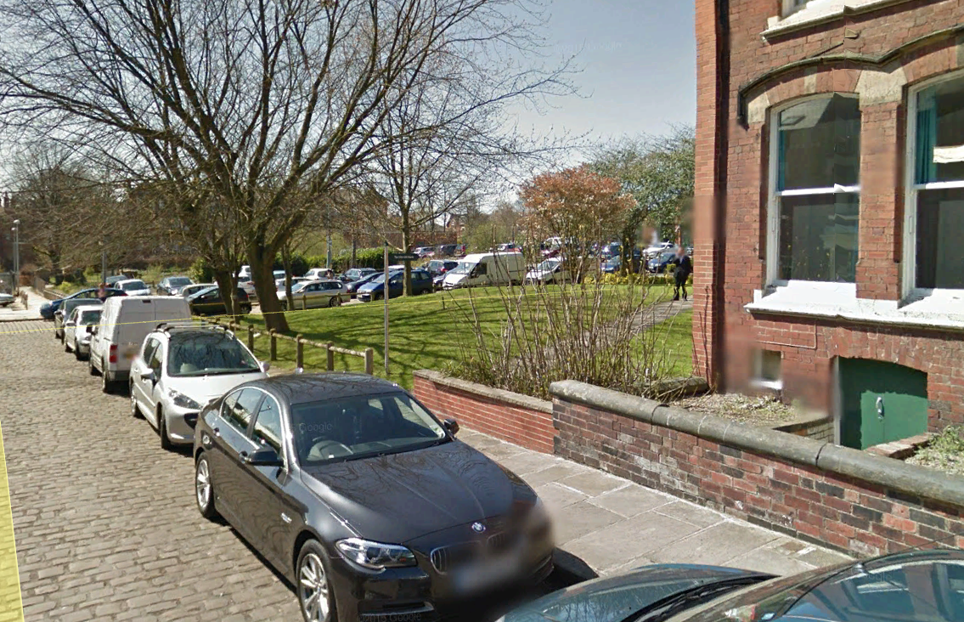

- 5-9 Willow Terrace Road – Behind the building on the grassed area near the car park
