How to set up a SLC professional password
We strongly advise all students who will be spending a year abroad or undertaking a work placement to set up a Professional Password before starting their placement or time overseas.

Having a Professional Password in place allows the University to speak to your student loan provider on your behalf if you have any questions or issues relating to your student loan. Without this password, the University is unable to act for you.
Even if you do not anticipate needing it, setting up a password in advance is strongly recommended, as it can be much more difficult to do once you are abroad or on placement.

You can do this either through your SFE account, or by calling your student loan provider. This document explains what you need to do for either option.

Online:
- Log into your online account

- Click on Undergraduate student finance applications (or Postgraduate, if appropriate):

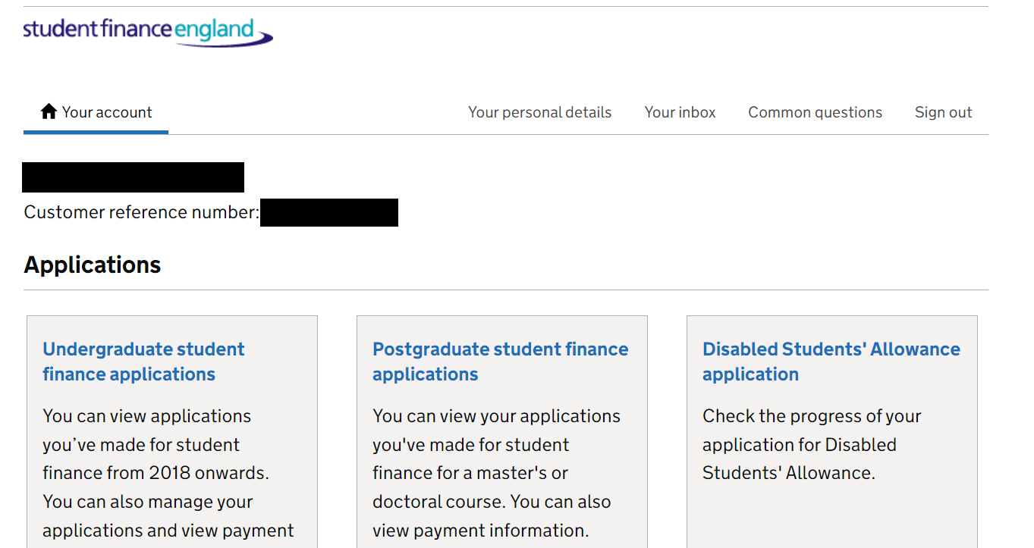
- Click on your most recent application:

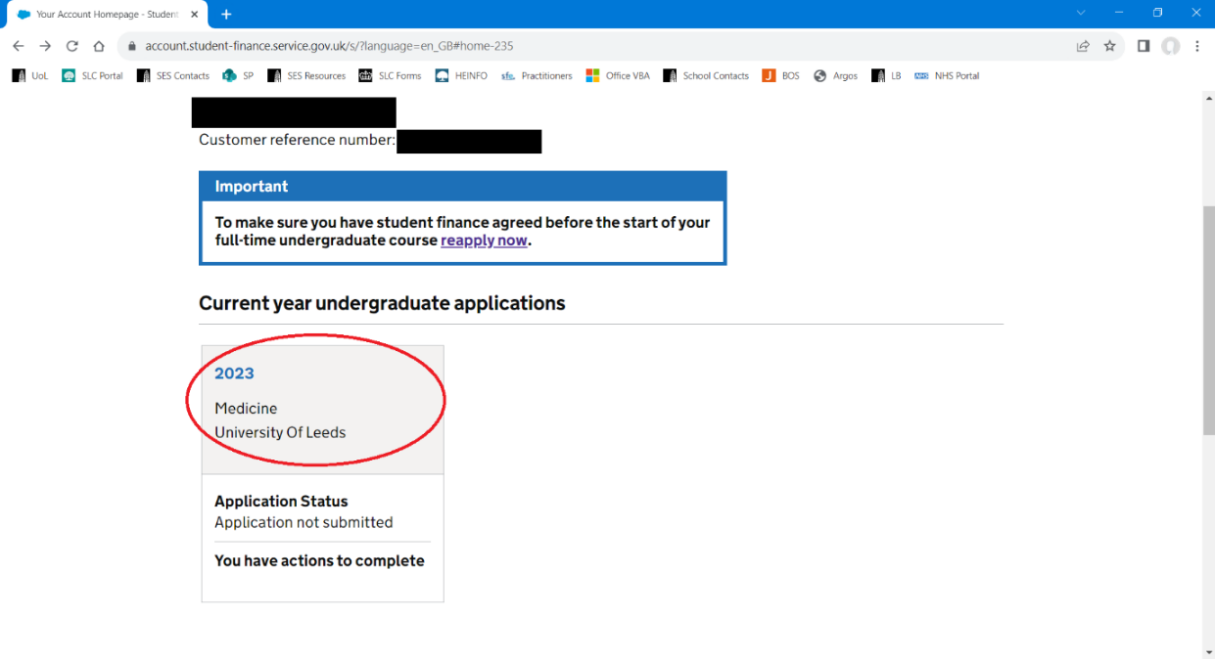
- Click on Share your student finance information in the ‘Manage your student finance’ menu:
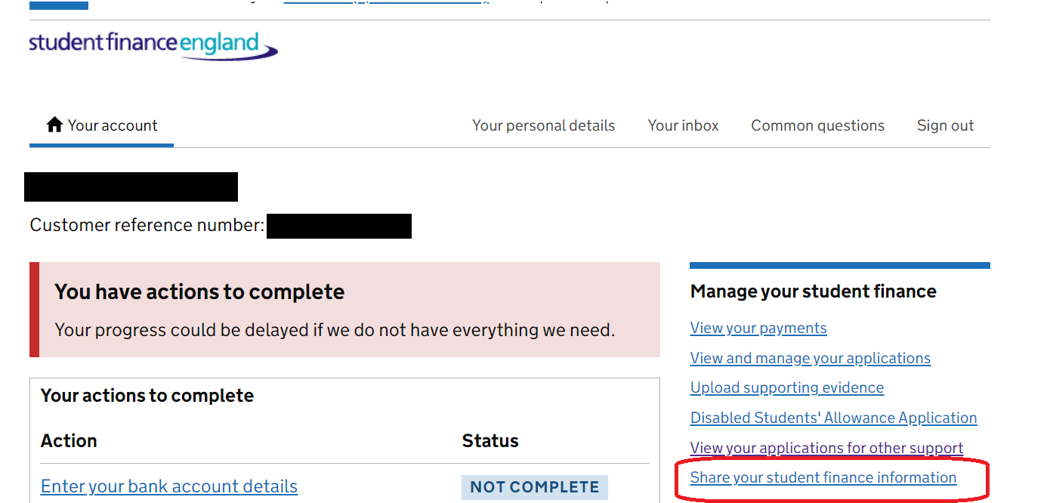
- Click Choose a person or organisation:
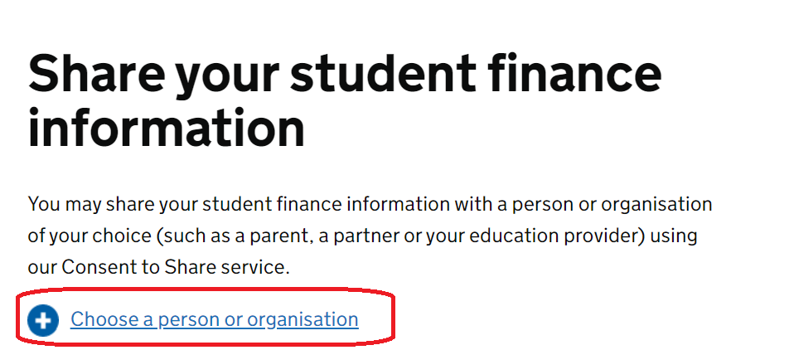

- Click Continue:
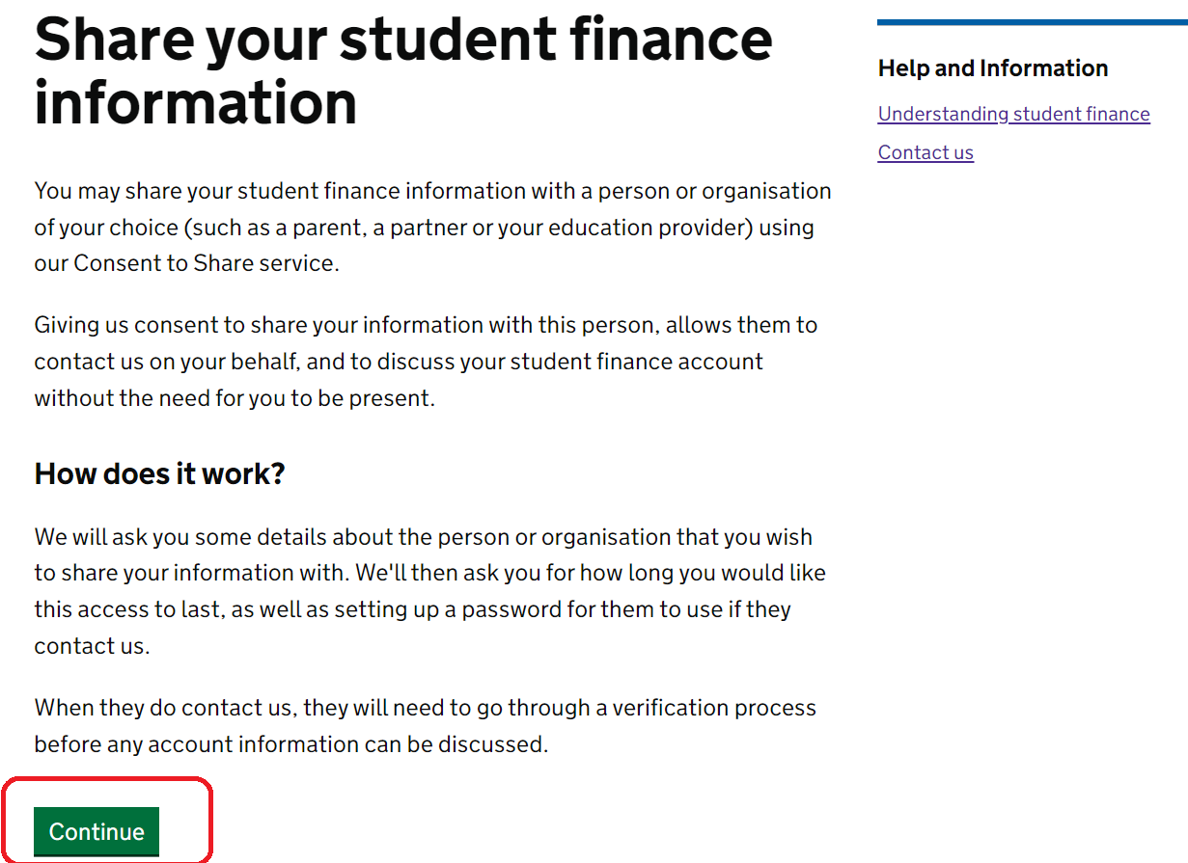
- Click Continue in the section called ‘What they can’t do’:
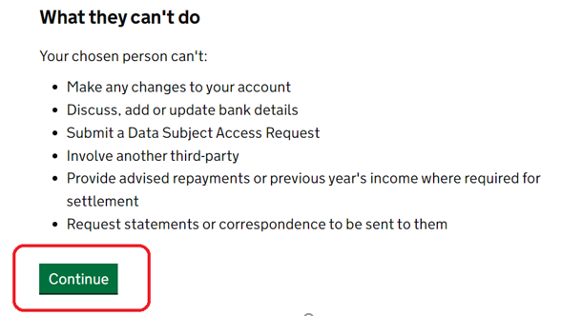
- Select An organisation, then click Continue:
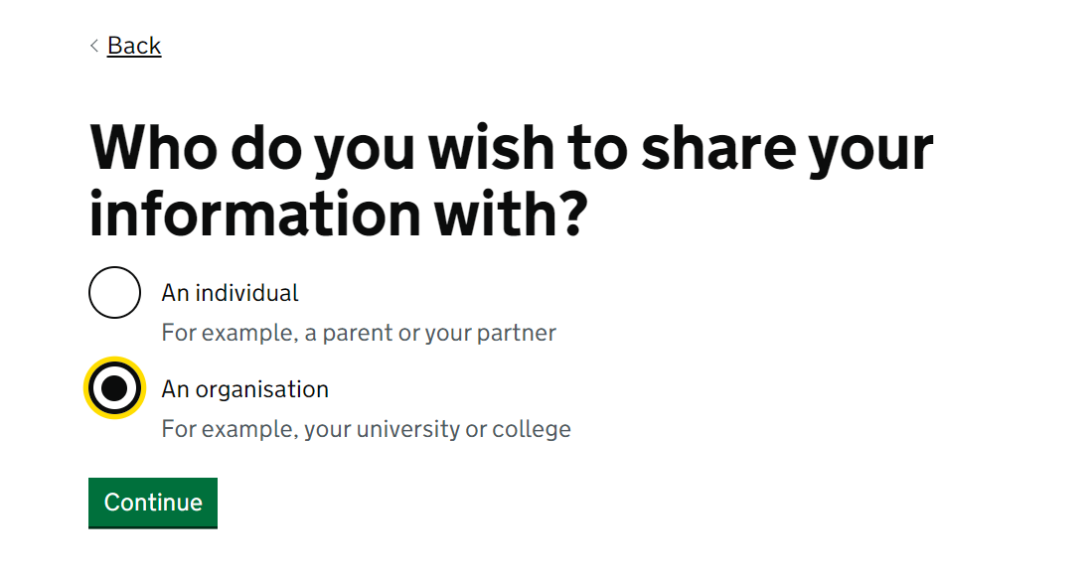
- Write The University of Leeds when asked ‘Who do you want to share your information with’ then click Continue:
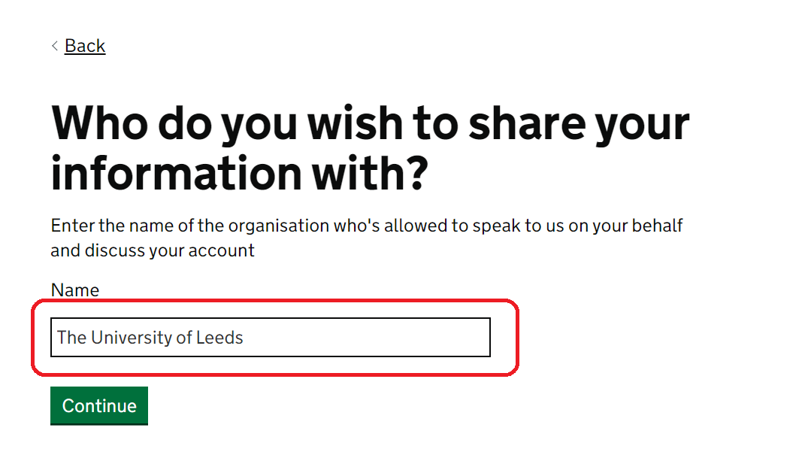
- Write Higher Education Provider when asked ‘What is their relationship to you?’ then click Continue:
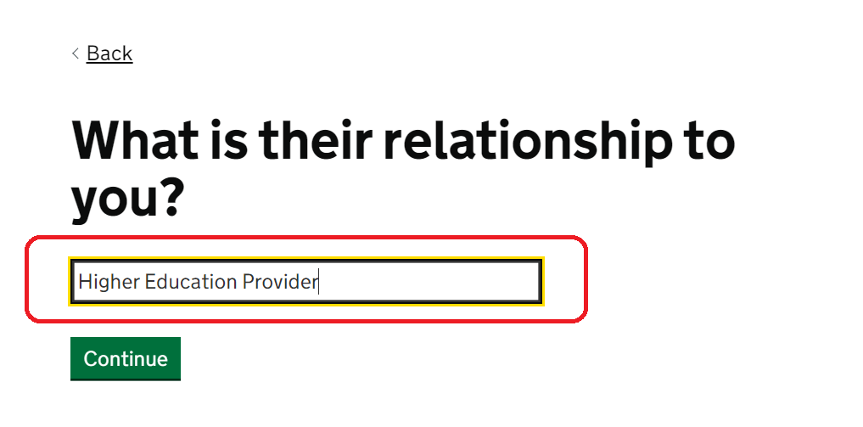
- Write in your chosen password, then click continue
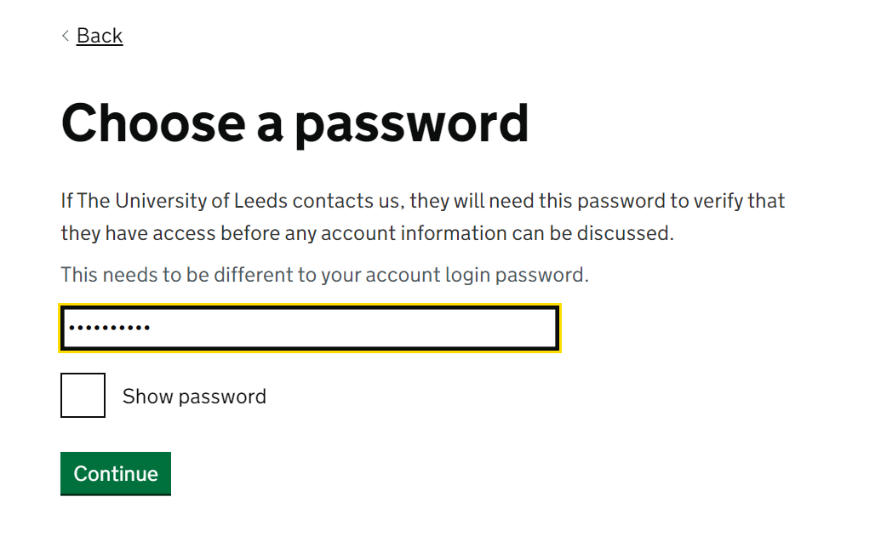

- Enter the date you want to stop the consent to share to be active. For example, if you wrote 31 in the box labelled Day, 12 in the box labelled Month and 2099 in the box labelled Year, it effectively means that you have given consent for us to share access your student finance information until 31 December 2099
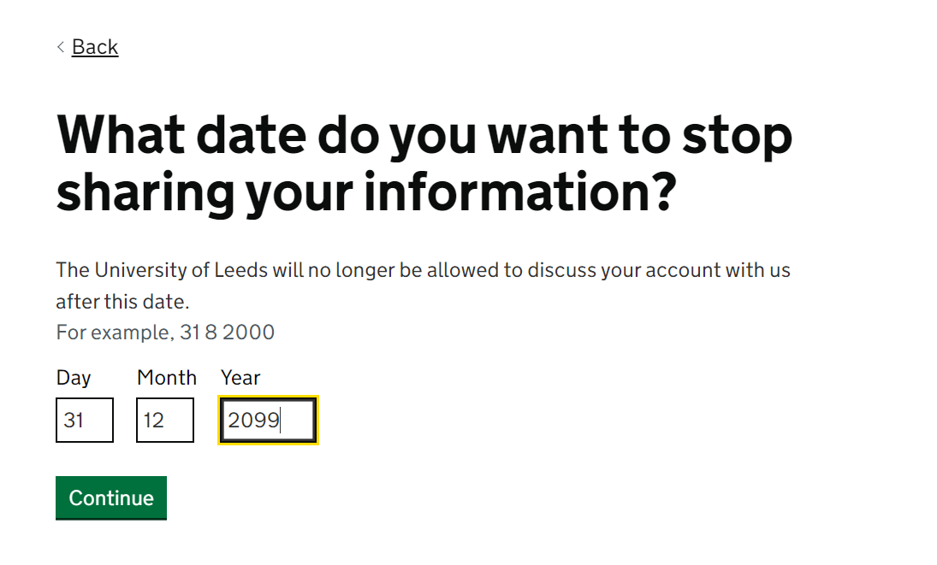
- You will then be able to review your answers. Make sure that you click Share my information in order for the consent to share to be made active.
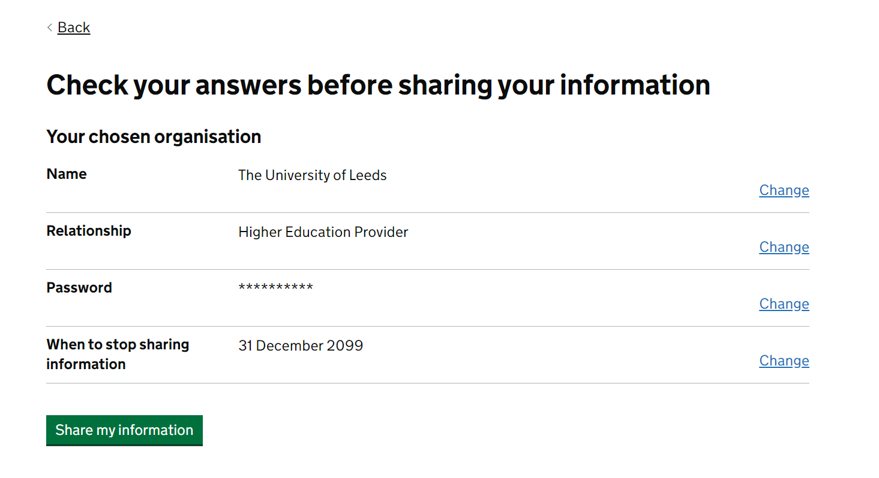

- You should then see a message that confirms you have given the University of Leeds access to your student finance information.
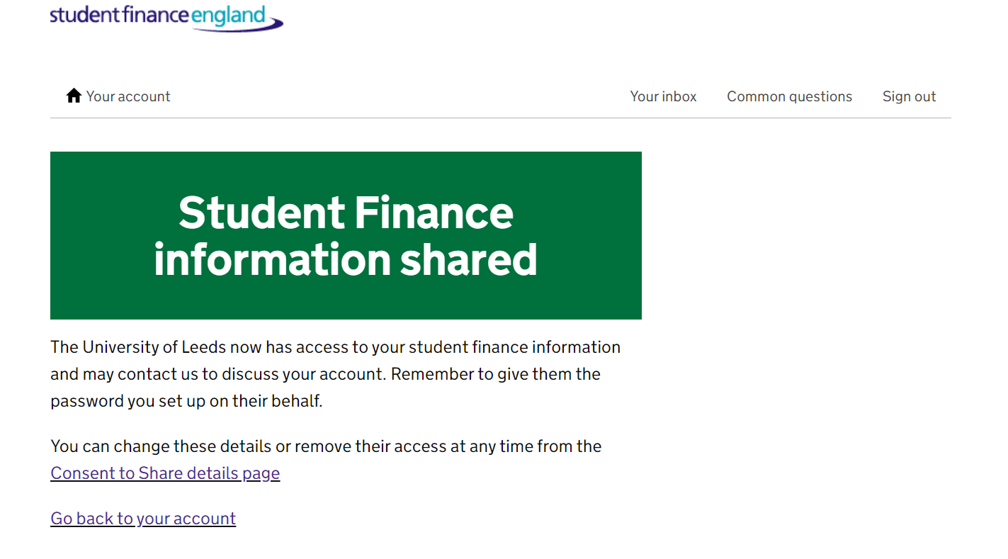

- Please email the Funding team at funding@leeds.ac.uk to let us know the password you have chosen. Include your student ID number in the email.

Calling your loan provider:
- Ask to set up a Professional Password.
- You will be asked who the password is for. You should answer: for the Higher Education Provider.
- You will be asked what your relationship is to the university, answer: My HE Provider
- You can then give your student loan provider a single word password. Please make a note of this and keep it safe.
- This means that if you do experience problems, you can contact placementfunding@leeds.ac.uk quickly to inform us what the password is, and we'll then be able to speak directly with your loan provider to try to help resolve the issue for you.

