Guidance for EU students going on a Study Abroad or Work Placement Year

- For continuing EU students who have a tuition fee loan from Student Finance England (SFE), each year SFE will post you paperwork to sign in order for you to receive the tuition fee loan for the coming year. The paperwork will include the name of the course you are on and its duration.
- EU students who are transferring onto a new course in order to undertake a Study Abroad or Work Placement year will need to update Student Finance England (SFE) with their new course details. This is done by completing an EUCO1 form, which can be downloaded from the Gov.UK website.

To complete the EUCO1 form:
- You should tick the box ‘I have changed course’ and then complete sections 1, 5, and 6.
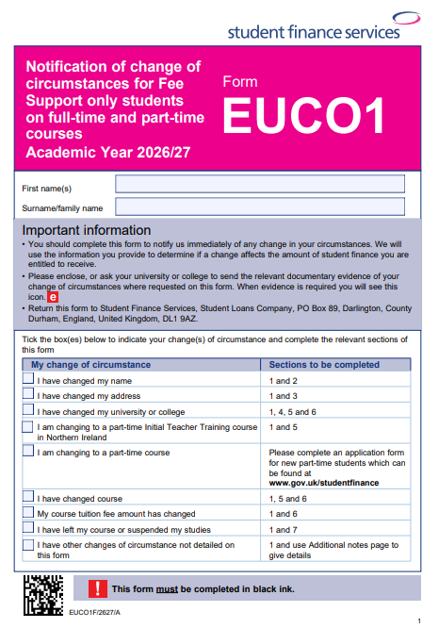

Section 1 is your personal details
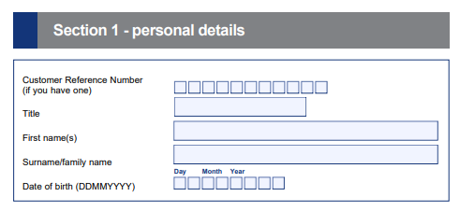

Section 5 is ‘change of course’:

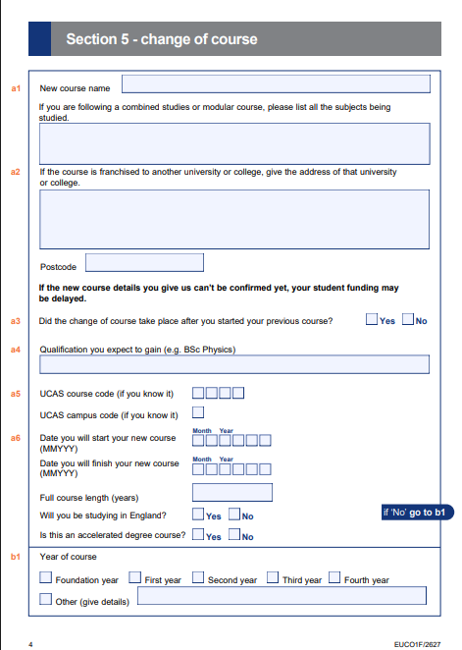

- a1 - put your new course name – this will be your current course title followed by (INT) if you’re going on a study abroad year or (IND) if you’re going on a year in industry
- a1 and a 2 - ignore the next two questions about combined/modular course and franchised university
- a3 – tick ‘Yes’ (you did change course after you’d started your previous course)
- a4 – enter the qualification you are studying for
- a5 – ignore this, there is no UCAS code for this course
- a6 – date you will start the new course is 09/2026
- a6 – date you will finish the new course is 07/2027
- a6 – course length is 4 years
- a6 – will you be studying in England, put ‘Yes’ (even though you’re on a study abroad year or a work placement year, you are registered at University of Leeds for the year and the tuition fee is paid to Leeds)
- a6 – tick ‘No’, this is not an accelerated degree
- b1 – tick 3rd year

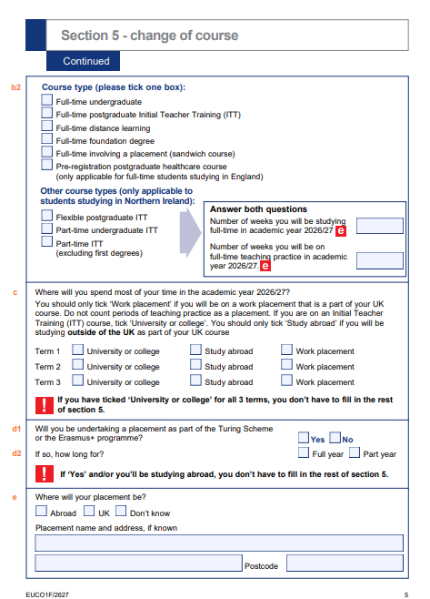

- b2 – tick ‘full time undergraduate.’ DO NOT tick ‘full-time involving a placement (sandwich course)’
- c – tick ‘study abroad’ or ‘work placement’ for all 3 terms
- d1 - tick ‘No’
- d2 – ignore this
- e – complete as appropriate (work placement only)

Section 6 is change of course tuition fee:

- If your tuition fee for a study year is normally £9,790, the tuition fee for the placement year will be £1,465.

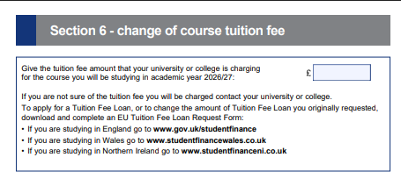

Don’t forget to sign and date the Declaration on page 7.

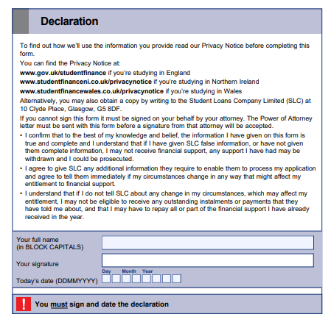

Important: You should still sign and return the paperwork that SFE send you every year for the loan and you should also include the completed EUCO1 form.

NB: the information on this document is for guidance only and students are advised to carefully check all the questions on the form and answer them appropriately to their circumstances. Any questions about the EUCO1 form, and how to complete this, should be directed to the SFE EU Helpline: 0141 243 3570
Updated 25/03/2026

