How to get the London Rate

- You must be working in London to receive the London rate from Student Finance England for a work placement year. The eligible work placement postcodes are EC, WC, N, NE, E, SE, S, SW, W, NW.
- Students living in London with parents receive the ‘Parental Home’ rate.
- You only need to be working in London to receive the London rate.

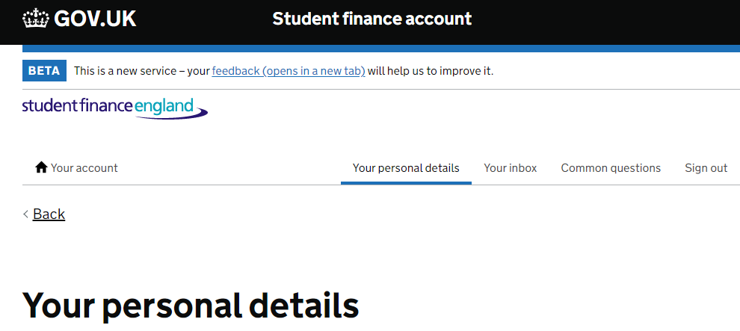

- In the ‘Your Personal details’ section of your online SFE account Leave your ‘Contact address’ as your permanent home address, do not replace it with your temporary address (such as a work placement address).

When you are applying for your funding:

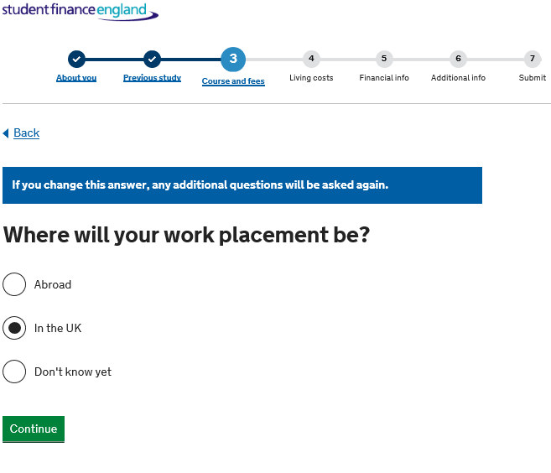
- You will need to select the ‘In the UK’ option when you are asked where your work placement will be
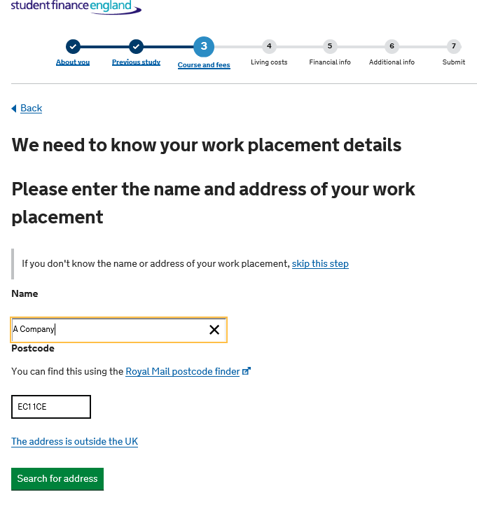

- You will then need to enter your employer’s address and postcode in Section 3 of the loan application when you are asked ‘Where will your work placement be?’ Remember – the address of the work placement must be in one of the approved London postcodes (EC, WC, N, NE, E, SE, S, SW, W, NW).

