How to apply for your student loan - work placement

First you will need to log in to your online Student Finance account and start a new application for 26/27.

Where do you plan to study?

Enter University of Leeds, as you will still be a registered student at Leeds. You are undertaking a work placement module as part of your undergraduate degree.

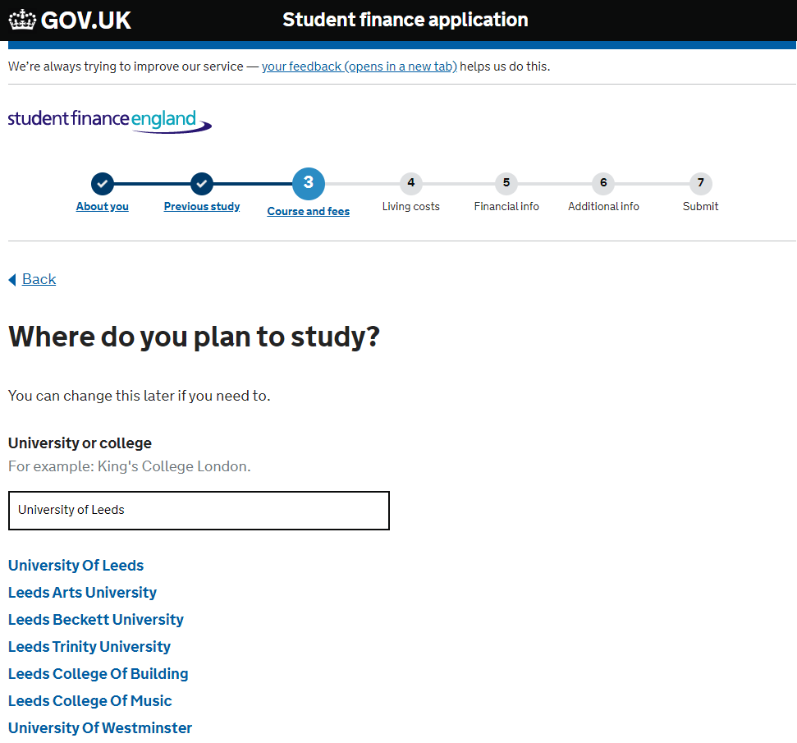

What course will you study at the University of Leeds?

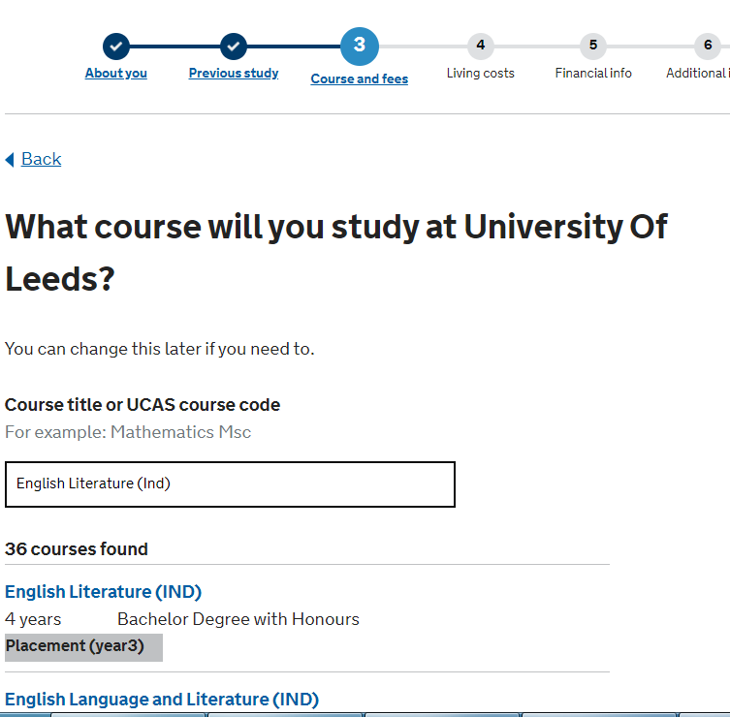
- Change your course title to the (IND) version if you’re going on placement in any year except your final year – i.e. you’re coming back to Leeds for another year of study after your placement year.
- Change your course title to the (IND) (inverted) version if you’re going on placement in your final year – i.e. the placement year will be your final year of your course and you’ll be graduating after this.

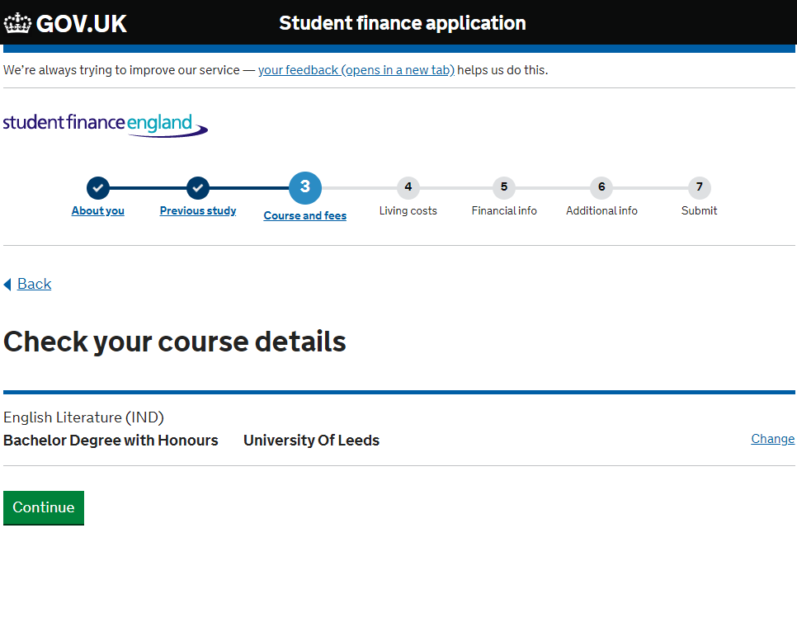

Did you attend this course last year?

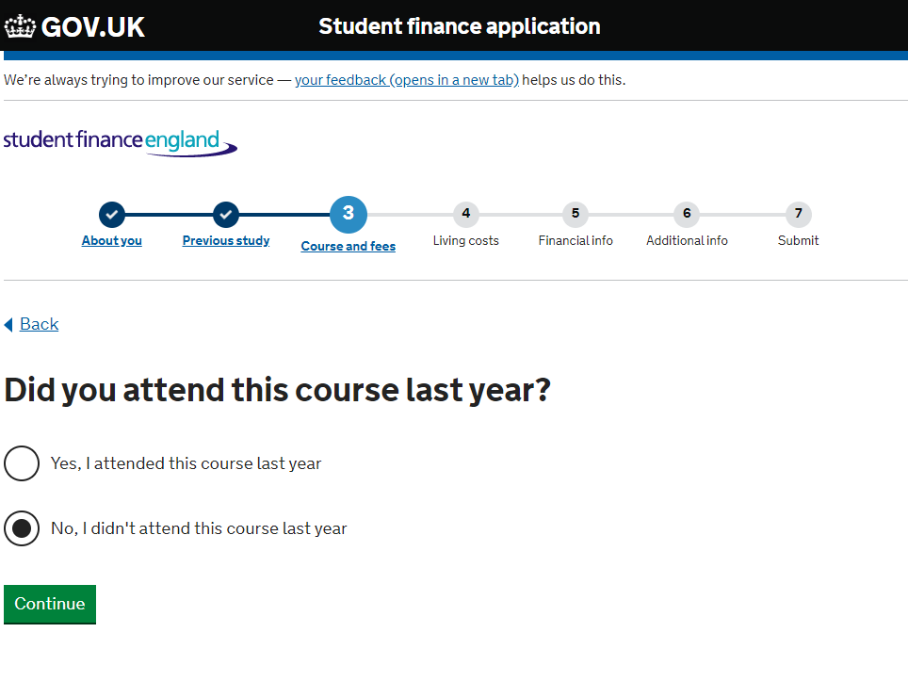
- If you’re on an (IND) course, tick ‘No’ as you’ll be transferring onto the course this year and were on a different course last year.
- If you’re on an (IND) (inverted) course, tick ‘Yes’ if you transferred onto this course last year, or ‘No’ if you’re transferring onto it this year and were on a different course last year.
- If you’re already on a course with a compulsory placement year, tick ‘Yes’ as you will have been on the same course last year
- If you’re transferring onto an (IND) (inverted) course and going into year 4 in 26/27, but you are on the final year of a 3-year course in 25/26 (so ticking ‘No’), you might find that you can’t submit an online application and you will need to complete a paper application (PR1 form).

Where will you spend the most time during the academic year?

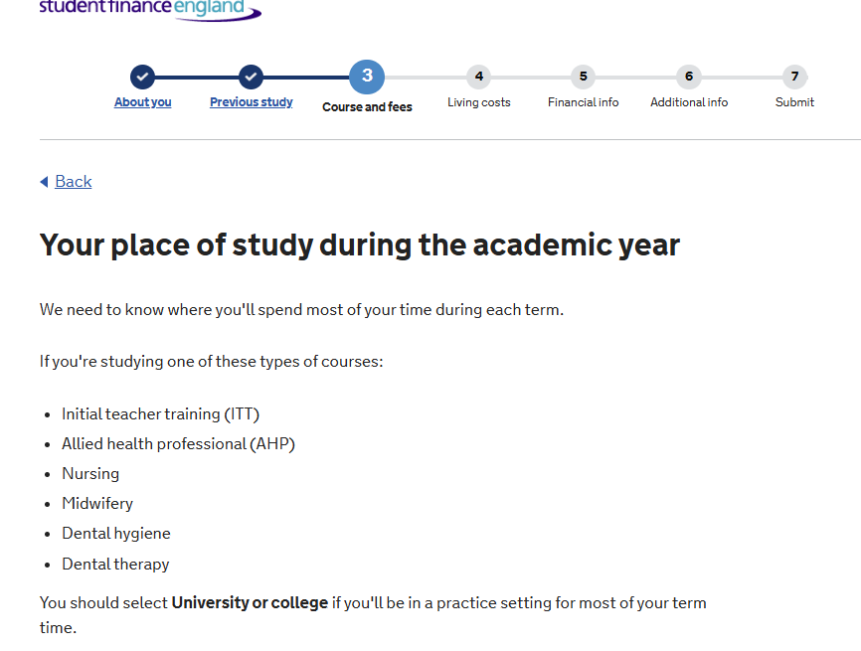
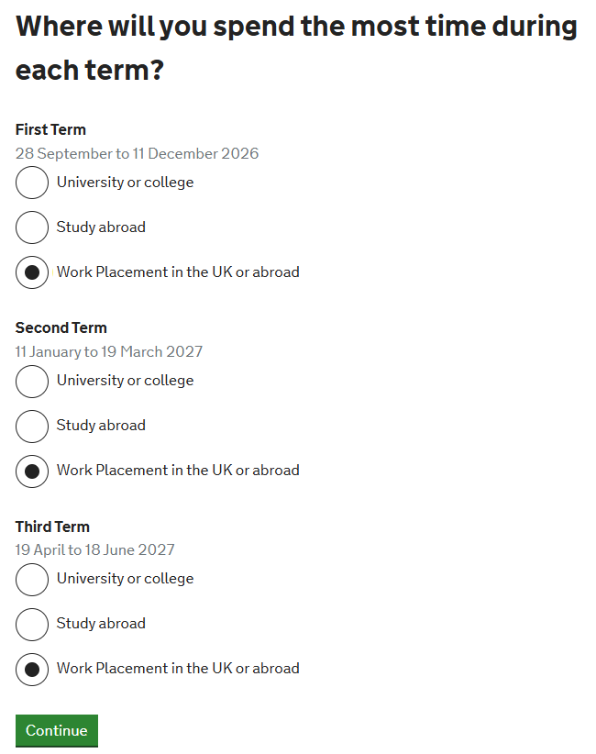
- Tick work placement for all 3 terms.
- If you’re on a Term Abroad, tick ‘University or college’ for all 3 terms. The University will update SFE during the year with your term abroad details so you can be assessed for the abroad rate in Term 3.

Where will your work placement be?

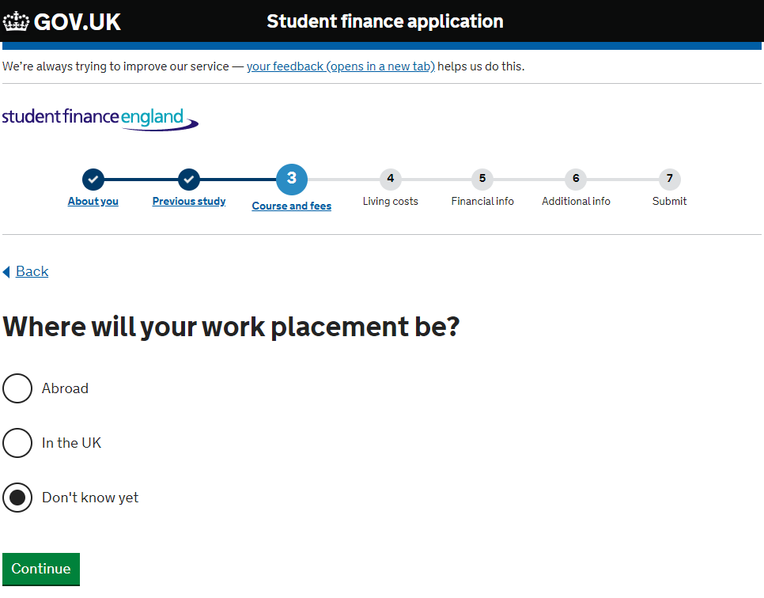
- Apply for your loan as soon as possible. If you’ve not yet secured a placement, tick the don’t know yet button.

Will you be paid for attending your work placement?
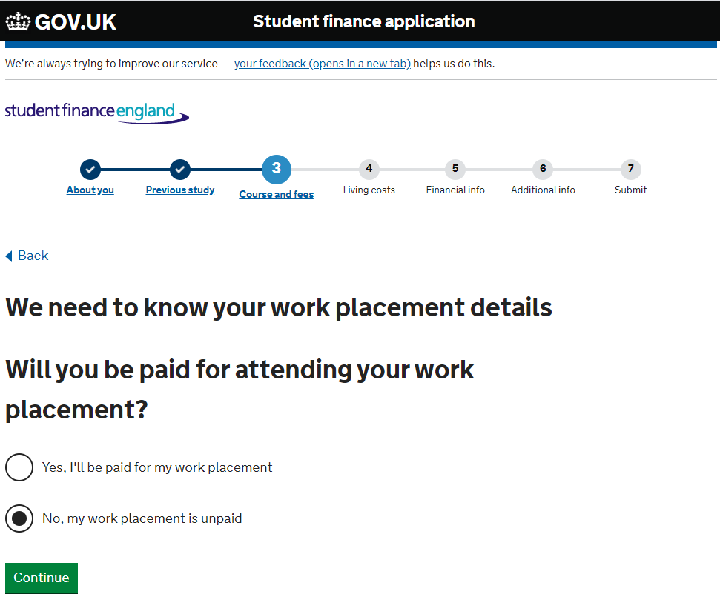
- If you tick ‘No’ for this question, you will then be asked ‘What kind of unpaid work placement is it?’
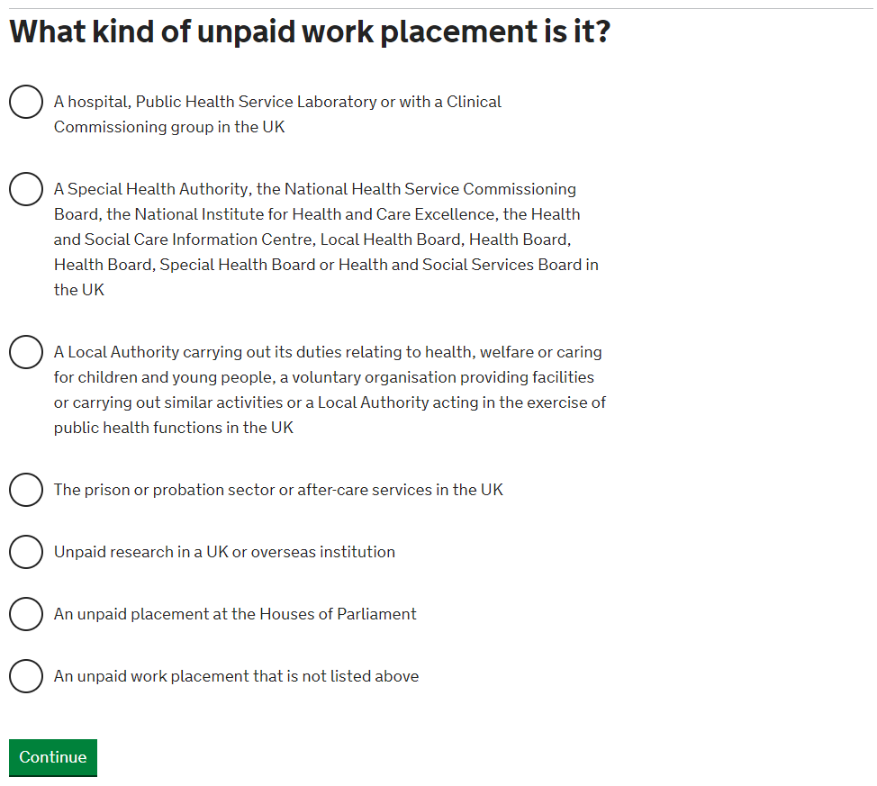
- If you are on a special case work placement, SFE will initially assess you for reduced funding, and will inform you that they need your university to confirm your placement details. When you receive this request from SFE, email placement-funding@leeds.ac.uk with the details of your placement. We will then confirm these with SFE and request that you are reassessed for full funding.

Have you been accepted onto the Turing Scheme or the Erasmus+ exchange programme?

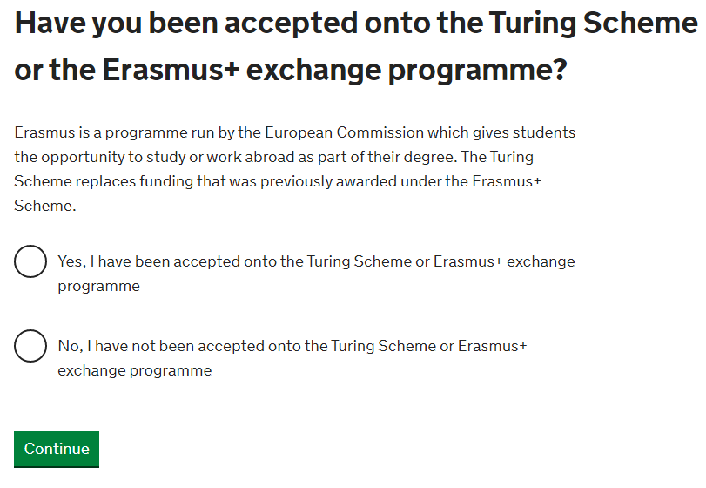
- Tick ‘No’ to this. Turing Scheme funding will be allocated later in the year and the University will update SFE if you have been accepted on the Turing Scheme. The Erasmus+ programme is no longer operating.

The Tuition Fee you’ll be charged for this year of study:

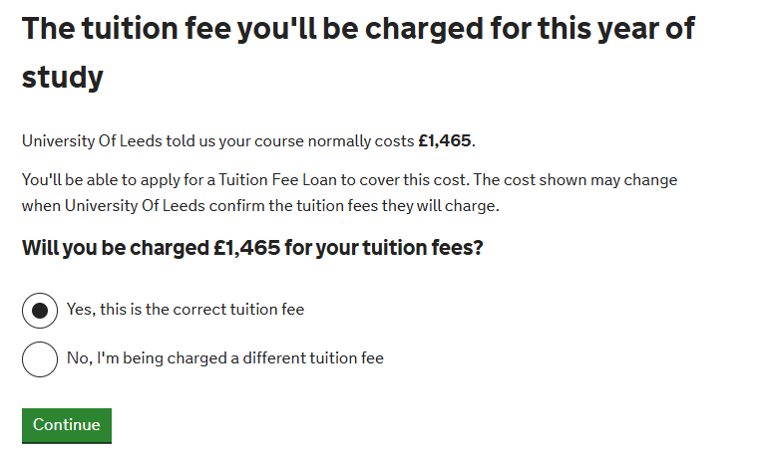
- Tick ‘Yes this is the correct tuition fee’ for this question if the tuition fee is listed as £1,465. This is the study abroad tuition fee for UK students whose fee for a standard year studying at Leeds is £9,790.

If you believe you have applied for your loan incorrectly:

If you have already applied for your loan, but for the 3 year course, or you find that SFE has rolled forward your 3 year course into 26/27, you can update your online application with your new course details by following the instructions on this video.

If you have any questions or concerns, please email the Funding team: placement-funding@leeds.ac.uk.

