How to apply for your student loan- study abroad

First you will need to log in to your online Student Finance account and start a new application for 26/27.

Where do you plan to study?

Enter University of Leeds, as you will still be a registered student at Leeds. Do not enter the host university – if you do this SFE will think you have left Leeds and started another course elsewhere.

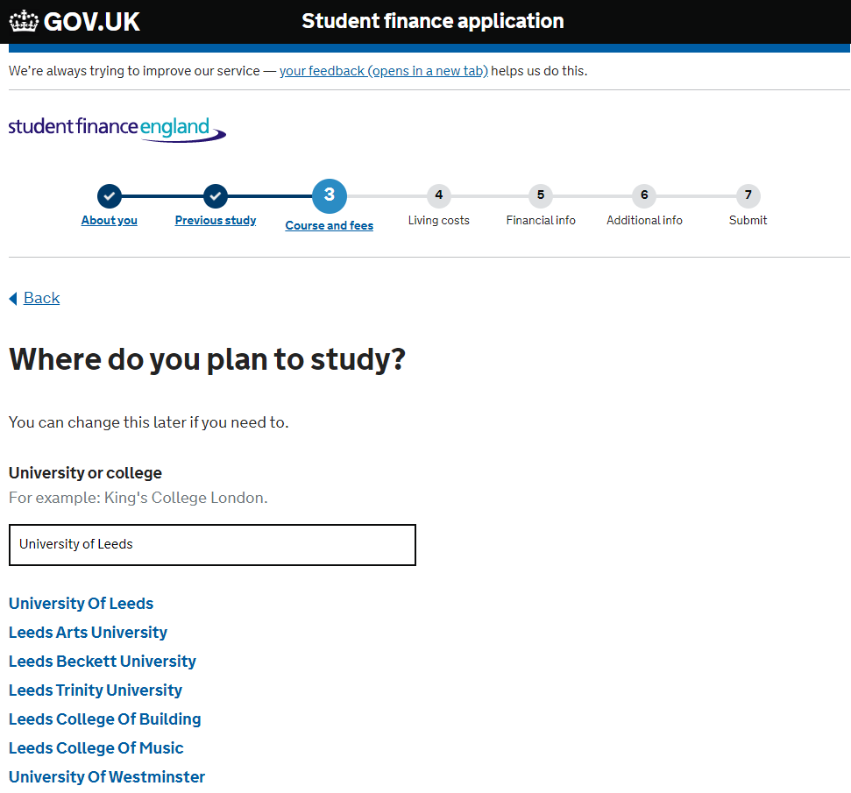

What course will you study at the University of Leeds?

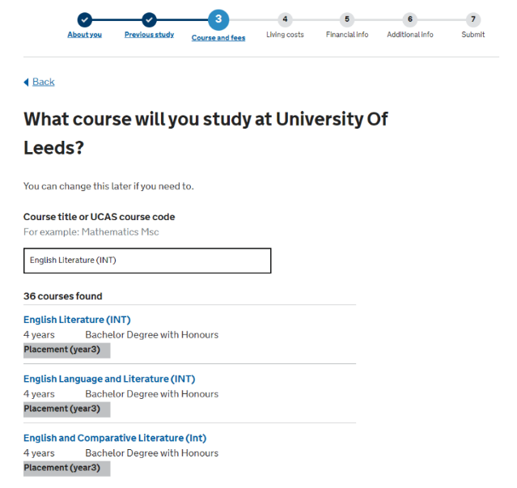
- Search for the name of your course and make sure you change your course title to the (INT) version if you’re going abroad in any year except your final year– i.e. you’re coming back to Leeds for another year of study after your abroad year.
- Search for the name of your course and make sure you change your course title to the (INT) (inverted) version if you’re going abroad in your final year – i.e. the abroad year will be your final year of study and you’ll be graduating after this.

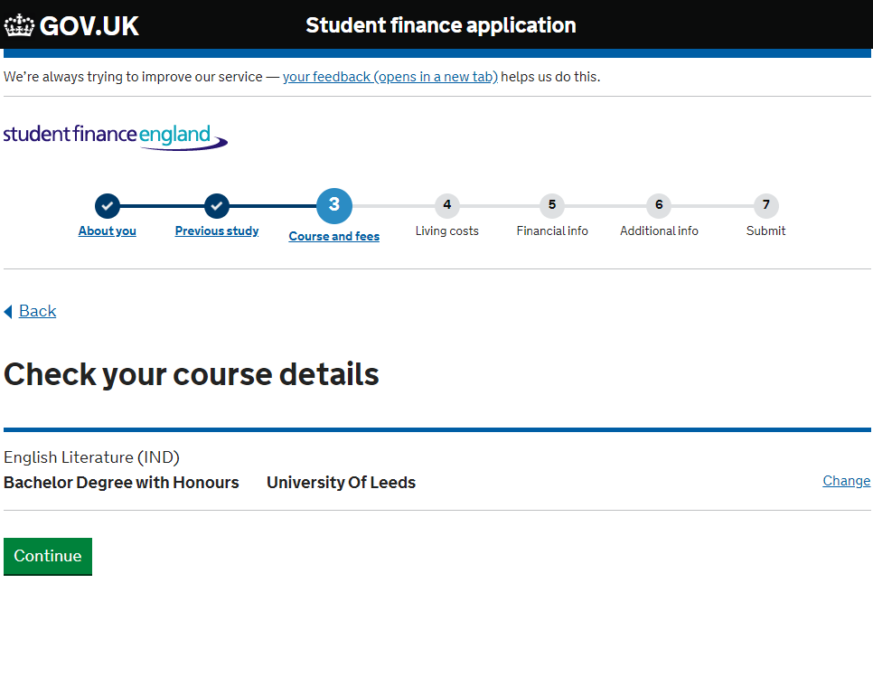

Did you attend this course last year?

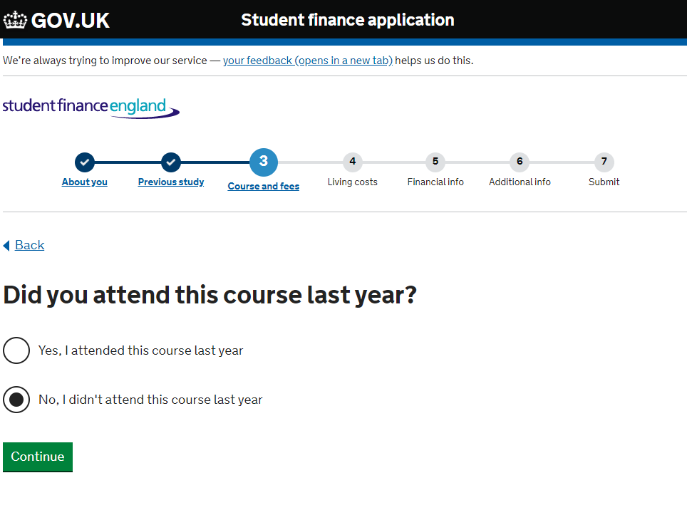

- If you’re on an (INT) course, tick ‘No’ as you’ll be transferring onto the course this year and were on a different course last year.
- If you’re on an (INT) (inverted) course, tick ‘Yes’ if you transferred onto this course last year, or ‘No’ if you’re transferring onto it this year and were on a different course last year.
- If you’re already on a course with a compulsory year abroad, tick ‘Yes’ as you will have been on the same course last year.
- If you’re transferring onto an (INT) (inverted) course and going into year 4 in 26/27, but you are showing as being on the final year of a 3 year course in 25/26 (so ticking ‘No’), you might find that you can’t submit an online application and you will need to complete a paper application (PR1 form).

Where will you spend the most time during the academic year?

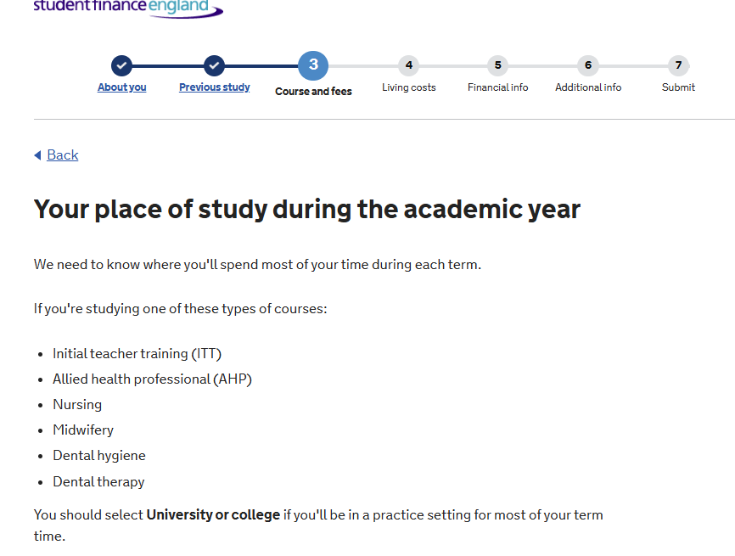
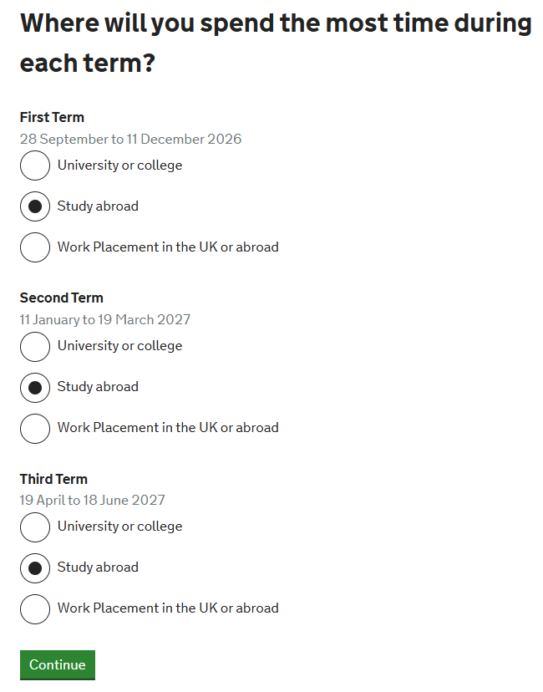
- Tick study abroad for all 3 terms. Do not tick University or college. If you do this SFE will think you are studying at Leeds.
- If you get a message asking you to upload evidence of your study abroad year, you can ignore this. You don’t need to send any evidence to SFE and the University will do this in June. Your loan application will be assessed by SFE Study Abroad team based on the information that we send to them
- If you’re on a Term Abroad, tick ‘University or college’ for all 3 terms. The University will update SFE during the year with your term abroad details so you can be assessed for the abroad rate in Term 3.

Have you been accepted onto the Erasmus+ exchange programme?

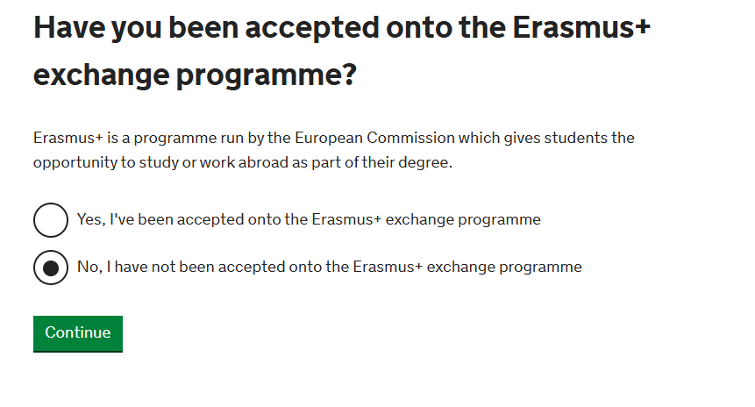
- Tick ‘No’ to this question as the Erasmus+ programme is no longer operating.

Have you been accepted onto the Turing Scheme or Taith exchange programme?

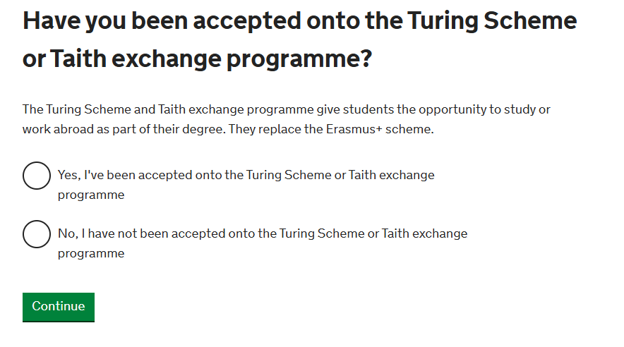
- Tick ‘No’ to this questions. Turing Scheme funding will be allocated later in the year and the University will update SFE if you have been accepted on the Turing Scheme.

The Tuition Fee you’ll be charged for this year of study:

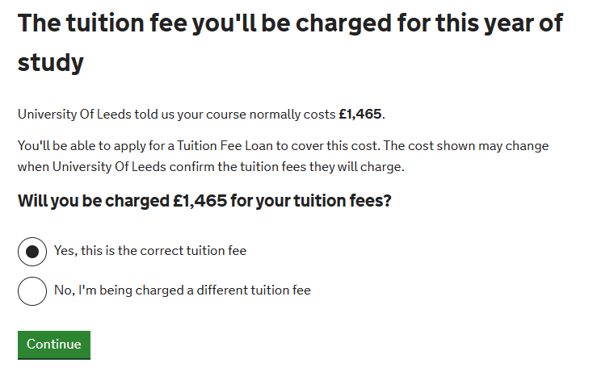
- Tick ‘Yes this is the correct tuition fee’ for this question if the tuition fee is listed as £1,465. This is the study abroad tuition fee for UK students whose fee for a standard year studying at Leeds is £9,790.

If you believe you have applied for your loan incorrectly:

If you have already applied for your loan, but for the 3 year course, or you find that SFE has rolled forward your 3 year course into 26/27, you can update your online application with your new course details by following the instructions on the Student Finance England video: How to change your student finance application (please note this video may not be suitable for users of assistive technology).
If you have any questions or concerns, please email the Funding team: placement-funding@leeds.ac.uk.

