ATAS application guidance for applicants, current students, and postgraduate researchers (PGRs)

This information is correct at the time of publishing (November 2025)

Contents

What is ATAS? 3
Who needs ATAS clearance? 3
When to apply for ATAS, what information you need from us, and how it links to your visa 3
If you are a new applicant and require an ATAS certificate: 3
If you are a current student or PGR and require a new ATAS certificate 3
What you need to complete your ATAS application 4
How to complete your ATAS application 4
Tips in answering the ‘Proposed Study’ questions 6
When will I receive a response? 11
What if I am refused ATAS clearance? 11
Deferring your start date: what you need to know 12
Who to contact for support 12

What is ATAS?
The Academic Technology Approval Scheme (ATAS) is a UK government clearance process required for international students/postgraduate researchers (PGRs) and researchers of certain nationalities who intend to study or conduct research in certain sensitive subject areas such as science, technology (including artificial intelligence), engineering and medicine.

Who needs ATAS clearance?
You will need ATAS clearance if:
- You are not a UK or EU/EEA national, and you are not exempt from the requirement to apply for an ATAS certificate.
- You are applying for a postgraduate taught course, research programme or attending Leeds as a visiting researcher, in a subject area where ATAS clearance is required.
- You are a current student or PGR who needs to reapply for ATAS due to changes with your main supervisor, programme end date, or—if you are a PGR—due to specific changes to your research project.

If you are an applicant, your offer letter will confirm whether ATAS clearance is required for your programme. If applicable, ATAS clearance is a condition of registration and must be obtained to support your visa application.
For applicants applying for a postgraduate research programme, this will be clearly stated in your offer letter and this will also include the Common Aggregation Hierarchy (CAH) code that you need to input into your ATAS application.
This is an example of the type of wording that would appear in a PGR offer letter (for illustrative purposes only — please refer to the specific information provided in your own offer letter):
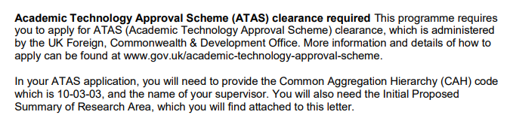
For taught student applicants, your offer letter will confirm if you require ATAS and will include a link that directs you to your CAH code and supervisor information.
If you are a current postgraduate researcher who requires new ATAS clearance, the Doctoral College will email you your CAH code.
If you are a current/returning student please contact your school who can confirm this information.

When to apply for ATAS, what information you need from us, and how it links to your visa

If you are a new applicant and require an ATAS certificate:
- You can apply for your ATAS certificate once you have received either a conditional or unconditional offer letter from us containing your Common Aggregation Hierarchy (CAH) code.
- You will also need to provide the information outlined in the ‘What will I be studying?’ section as part of your ATAS application.
- You require ATAS clearance before your student visa application can be approved
- Once issued, your ATAS certificate is valid for six months and must be used within that time as part of your visa application.
If you receive an updated offer from us, you may need to reapply for your ATAS clearance.

If you are a current student or PGR and require a new ATAS certificate
If you already hold an ATAS certificate, you must apply for a new one within 28 days of any of the following changes being confirmed. Failing to do so may affect your permission to study in the UK.
- A change to the length of your programme (eg your end date is extended by three months or more due to temporary leave, suspension, or an approved extension)
- A change to your research methodology, technology, or intended application, for example, moving from desk-based to lab-based work, introducing high-performance computing, or using advanced AI techniques (eg machine learning, computer vision, autonomous systems), especially where there may be potential applications in sensitive areas such as security, defence, or surveillance.
- A change to your main or primary supervisor
- A change to your parent school (this may happen if your research project or supervisor changes)
- You need a new student visa
If any of these changes apply to you, please notify your Graduate School or school as soon as possible.
Please also refer to the ‘What will I be studying?’ section of this document.

What you need to complete your ATAS application
Before starting your ATAS application, please ensure you have the following information ready:
- Offer letter
- PGRs will also require their research statement issued by their primary/main supervisor
- Passport details
- Details of previous study including academic qualifications and employment
- Details of any previous ATAS applications
- Full names and contact details of (at least) two referees
- You must have known your referees for at least three years.
- At least one of them must be an academic reference.
- Although the guidance on the form states that at least one of your referees should be “from your country of origin” (meaning the country where you were born), this may not be possible if you have lived elsewhere for several years. In this case, please provide a referee based in the country where you have lived the longest.
- If you have work experience, you should include a referee from your employment. Family members are not accepted as referees.
- Details of any published papers
- Information about how you will be funded
As part of your ATAS application, you’ll need to provide details about how your studies will be funded—whether through a training or research grant, or by the University. If you have multiple sources of funding, you must provide information for each sponsor.

You will need to include:
- Name of your sponsor
- Sponsor’s address
- Country where your sponsor is based
- Sponsor’s contact email address
- Any conditions attached to the funding

How to complete your ATAS application
You can find more information about applying for ATAS clearance on the UK Government website, including their official guidance notes for applicants.

Set up your account
Please use this link to access the portal on the ATAS website
Please enter your personal email address and create a password as directed on screen.
If you already have an account, please click ‘Sign in’ located in the top right corner of the page. If you are a current student or PGR and making changes to an existing ATAS application, please log in using the details you used for your original application (do not create a new account).
When registering for your ATAS account, we recommend using a widely recognised email provider (such as Outlook or Yahoo) and avoiding regional providers, which may cause issues with receiving important messages.
If you experience difficulties during registration, try switching to a different web browser such as Google Chrome or Microsoft Edge for the best experience.

Selecting the correct status
Please access the application portal
One of the first questions on the application form will ask you to declare whether you are a Taught/Research student or Researcher (see following example).
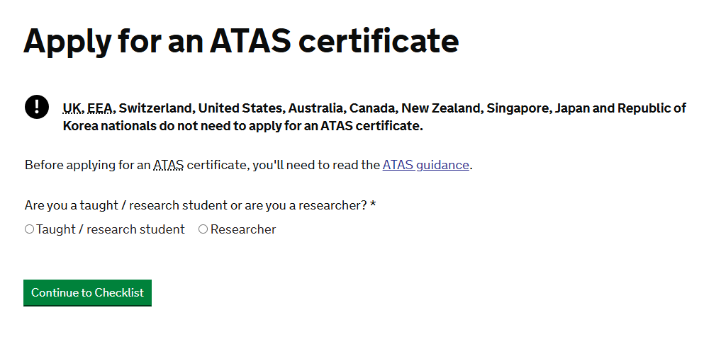
If you have received a conditional or unconditional offer letter from us, or are extending your student visa, select ‘Taught/Research student.’
If you are visiting the University of Leeds and are currently registered as a student or PGR at another institution (either in the UK or internationally) select ‘Taught/Research student’ even if you will be undertaking some paid work during your time with us.
You should only select ‘Researcher’ if you are attending the University of Leeds as a member of staff or visiting academic staff.
Then please select the type of study that you will be undertaking:
If you are intending to study a research programme, select ‘Research’. Examples of research programmes include:
- PhD,
- MD,
- EdD,
- DPaedDent,
- DClinPsychol,
- DClinEd,
- Integrated PhD MSc,
- PhD with Integrated PG Cert,
- MPhil, MSc by Research,
- MSc (Eng) by Research,
- MA by Research.
If you are you intending to study a postgraduate taught degree, select ‘Taught’. Examples of postgraduate taught courses include
- MEng,
- MSc (Eng),
- MSc.
Your programme is listed on your offer letter.

Tips in answering the ‘Proposed Study’ questions
This section provides extra guidance to help you complete your ATAS application form accurately. We have included tips and clarifications only for the questions where we believe additional support will be most helpful.
If you need further assistance at any stage, please don’t hesitate to contact us.

Which university?
The university you will be studying at is the University of Leeds.

Subject
You will be asked to enter the subject of your course as part of your ATAS application.
For taught students please enter your course name as indicated in your offer letter. This is an example of how this will appear in your offer letter:
For PGRs, you can find this information on your offer letter. Please refer to the following examples to help you complete this section accurately.
Example 1
If your offer letter states ‘Provisional PhD’ or ‘Postgraduate Research’ in the Programme description field of your offer letter, please enter the ‘School’ name in the subject field of the ATAS application (please see the following example 1).

In this example you would enter the subject as Design as the subject. You do not need to add ‘School of’.
Example 2
For all other degrees please enter the subject listed in the Programme description from your offer letter.
In this example you would enter the subject as Paediatric Dentistry as the subject. You do not need to include the degree type (DPaedDent).

Course start date
Enter the start date as noted in your offer letter.
If you are a current student or PGR applying for new ATAS clearance, please enter the date you submit your application as the course start date. You cannot enter a date in the past, so the submission date must reflect the current date.

Expected course end date:
For taught students, visiting postgraduate researchers and master by research students: this is the date noted in the ‘end date’ field in your offer letter. If you are a current taught student and have had temporary leave your school will confirm your end date.
For all other PGRs: this is the ‘thesis submission deadline’ listed in your offer letter (see the marked-out section in the following image). If you are a current PGR please find this date on your GRAD record. Please do not enter the date noted in the ‘end date’ field of your offer letter.
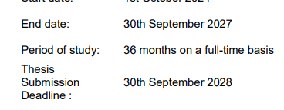

What is my CAH3 (Common Aggregation Hierarchy) code?
For taught students – Your offer letter will direct you to the correct Coursefinder page, which includes detailed information specific to your course.
For PGRs - You will receive the necessary course information either in your offer letter or by email from us when it is time to apply for new ATAS clearance.
Please contact us if you need further information.

What qualification will I be studying for?
Taught student - this will be noted in your offer letter in the ‘course’ field.
Example 1 (Taught students)
Course: MSc (Eng) Advanced Mechanical Engineering
You would answer: MSc
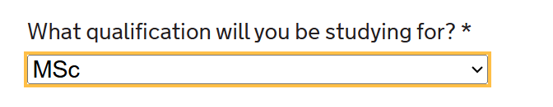

PGR – this will be noted in your offer in the ‘Programme’ field. Some examples are provided as a reference.
Example 2 (PGR):
Programme: Provisional PhD
You would answer ‘PhD’
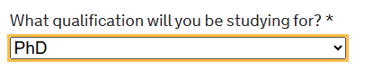

Example 3 (PGR):
Programme: DPaedDent Paediatric Dentistry
You would answer ‘Professional Doctorates’
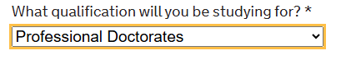

Example 4 (PGR):
Programme: Postgraduate Student Visitor
You would answer ‘Other – not a UK qualification’
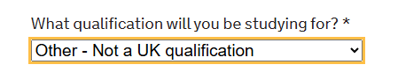
Supervisor name at UK University
Taught students – your supervisor (or programme lead) is referenced on our Coursefinder page – a link to this is provided in your offer letter.
PGR - enter the name of your main (or primary) supervisor. This is the person is named on the ‘Initial Proposed Summary of Research Area – Academic Technology Approval Scheme’ form, which will be sent to you with your offer letter.

What will I be studying?
This section of the ATAS application has a 2,000-character limit.
Details of the information you should include are provided here.
Taught student applicant - please provide a list all the compulsory modules for your course, along with any optional/elective modules that you plan to study, if applicable. Module information is available at catalogue.leeds.ac.uk.
PGR applicants, including visiting postgraduate researchers - must submit the research statement provided in the document titled ‘Initial Proposed Summary of Research Area – Academic Technology Approval Scheme’, which accompanies your offer letter. Do not make any changes to this statement.
If you are part of a degree programme that involves a collaborative partner—either in the UK or overseas—your primary (or main) supervisor should have included this in the research statement.
This applies to programmes such as:
- Split-site and dual award programmes
- Centres for Doctoral Training (CDT)
- Doctoral Focal Awards (DFA)
- Doctoral Training Partnerships (DTP)
- Doctoral Landscape Awards (DLA)
- Doctoral Training Networks (DTN)
If this information has not been included, you should either ask your primary (or main) supervisor to revise the research statement to include it, or you may add a brief note before the statement to clarify the collaboration.
For example:
“This course is delivered in collaboration with the following partner universities: [Insert list of universities].”
Current taught student - Please list any outstanding modules you still need to complete (including optional modules and electives), along with your reason for reapplying.
For example: “I took an approved temporary leave from my studies between January and June, and am applying for new ATAS clearance to continue my course.”
Current PGRs - If you already hold an ATAS certificate, you must apply for a new one within 28 days of any listed changes being confirmed.
If you do not apply for new ATAS clearance within this period, your permission to study in the UK may be affected. In some cases, you may need to suspend your studies until the new clearance is received.
We will email you a research statement to use in your ATAS application. Do not make any changes to this statement, and do not write your own version. It should be provided by your primary (or main) supervisor.
Your supervisor should clearly state the reason for the new ATAS clearance application in the research statement.
In addition, if you are part of a degree programme that involves a collaborative partner—either in the UK or overseas—this should also be included in the statement. This applies to programmes such as split-site or dual awards, Centres for Doctoral Training (CDT), Doctoral Focal Awards (DFA), Doctoral Training Partnerships (DTP), Doctoral Landscape Awards (DLA), and Doctoral Training Networks (DTN).
If any of this information has not been included in the research statement, you should either ask your primary (or main) supervisor to revise the statement to include it, or you may add a brief note before the statement to clarify the reason for the new ATAS clearance and/or the collaborative nature of the programme.
If you have any questions, please contact us.

Joint programme?
PGR – if you are a visiting postgraduate researcher or registered on a dual award or split site programme you should answer ‘Yes’ to this question This information is normally found in your offer letter, however please contact us if you require clarification.
PGR/Taught student – If you will only study at the University of Leeds (i.e. there is no joint or collaborative partner involved) you should answer ‘No’ to this question.
If your course includes a year abroad, fieldwork or placement, but your degree will be awarded solely by the University of Leeds, you should answer “No” to this question.

When will I receive a response?
Once you’ve submitted your application, you should wait on a decision. This takes at least 30 working days (6 weeks - this information is correct at the time of publishing). Your decision will be sent by email, alternatively you can also log in to your ATAS account to check the status of your application.
If you are a current PGR please forward your email confirmation of application to us on rp_student@adm.leeds.ac.uk.
If you are a current student please forward this information to your school.
Please be aware that the ATAS portal detects and blocks duplicate applications. If you try to submit more than one, the Foreign, Commonwealth & Development Office (FCDO) will ask you to withdraw any active applications before a new one can be considered.
Unfortunately, it’s not possible to fast-track ATAS applications, even if your application has taken longer than the usual processing time.
You must obtain ATAS clearance before starting your course. This requirement applies whether you are beginning your studies remotely or are already in the UK with existing immigration permission.
If you are a current PGR, confirmation that your ATAS application has been submitted to the FCDO is sufficient for you to continue your research while awaiting a decision.

What if I am refused ATAS clearance?
If you receive notification that your ATAS application has been refused, please contact us promptly for advice. You must not reapply until you have consulted with us.
If you are a current student or PGR, you should also contact the Student Visa Advice Team (studentvisaadvice@leeds.ac.uk) at the University of Leeds as soon as possible to understand any implications for your student visa.

Deferring your start date: what you need to know (PGR only)
If you are a PGR applicant and need to defer your start date whilst your ATAS application is still being processed, you can log in to the ATAS portal and update your course start and end dates.
If you’ve already received ATAS clearance, you’ll need to apply again if
- your certificate is no longer valid or
- your certificate remains valid but your new course end date is more than three months later than the one listed in your approved certificate.
If any other course details have changed and ATAS clearance is required, this will be indicated in your offer letter.
Taught PG students are not usually able to defer to the following year. Instead, you will need to reapply for your course and then if are you successful, reapply for ATAS via the same process as your first application. If you think you may need to defer, please contact the admissions team stated on your offer letter.

Who to contact for support
- Applicants - Taught student and PGRs: please contact the admissions team using the email noted on your offer letter or alternatively study@leeds.ac.uk
- Current PGRs: rp_student@adm.leeds.ac.uk plus your Graduate School
- Current students: please contact your school
- Student visa advice team– studentvisaadvice@leeds.ac.uk

