# **How to get the London Rate**

* You must be **working** in London to receive the London rate from Student Finance England for a work placement year. The eligible postcodes are **EC, WC, N, NE, E, SE, S, SW, W, NW**.
* Students living in London with parents receive the ‘Parental Home’ rate.
* You only need to be working in London to receive the London rate.

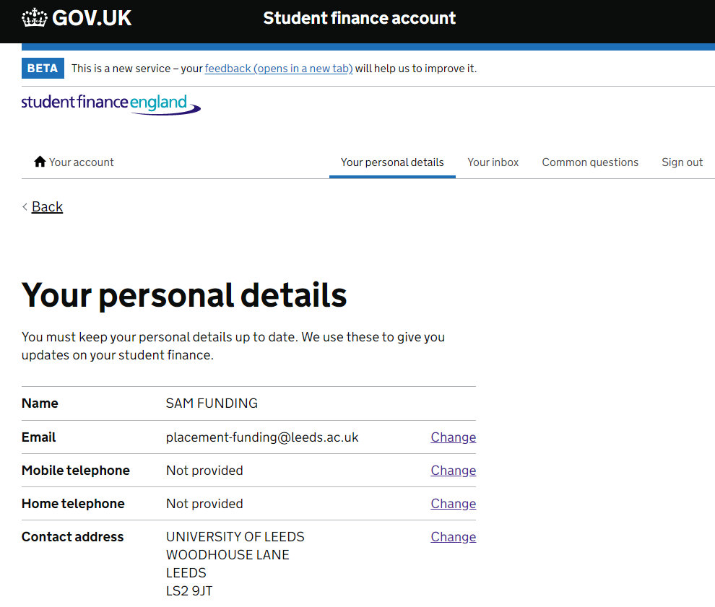

* In the ‘Your Personal details’ section of your online SFE account Leave your ‘Contact address’ as your permanent home address, do not replace it with your temporary address (such as a work placement address).

## When you are applying for your funding:

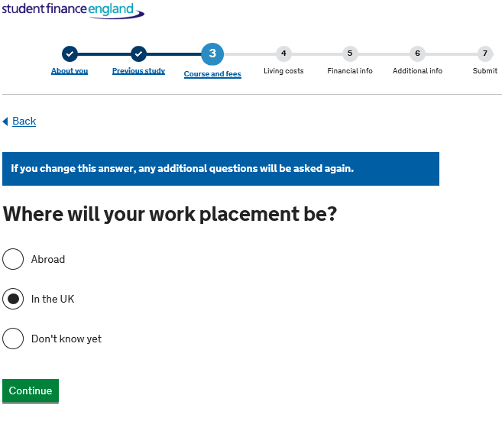

1. You will need to select the ‘In the UK’ option when you are asked where your work placement will be

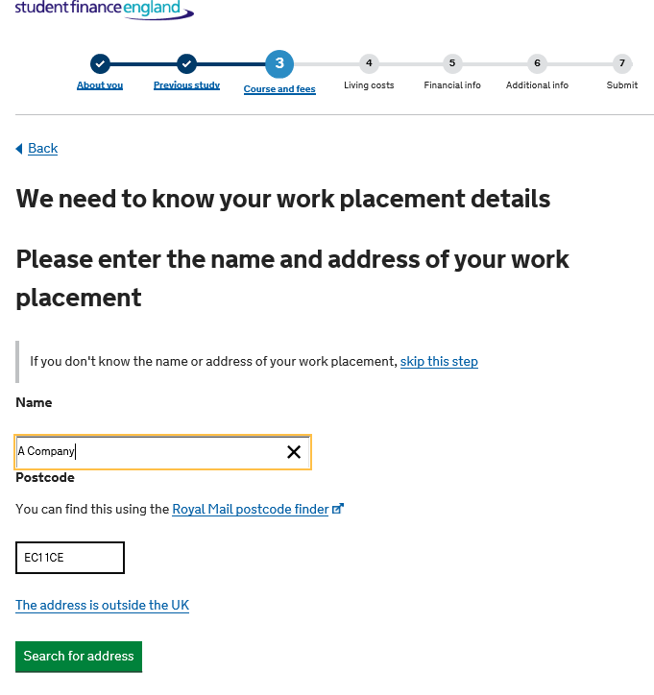

1. You will then need to enter your employer’s address and postcode in Section 3 of the loan application when you are asked ‘Where will your work placement be?’ Remember – the address of the work placement must be in one of the approved London postcodes (EC, WC, N, NE, E, SE, S, SW, W, NW).