This document shows how you can make changes to your application from your online SFE account.

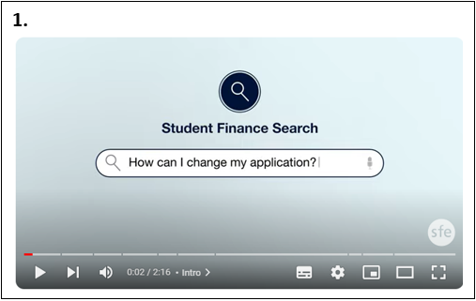

1. First, you will need to navigate to the Student Finance England website.

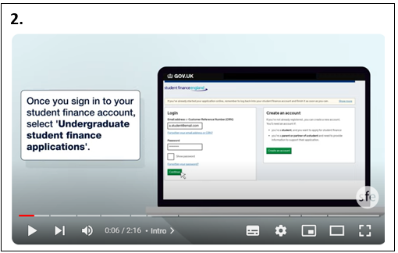

1. You will need to sign into your online Student Finance account.

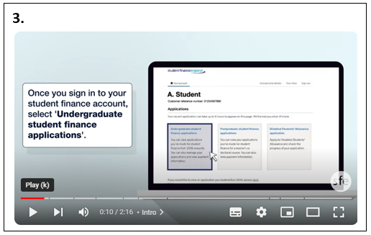

1. You will then need to select ‘Undergraduate student finance applications.

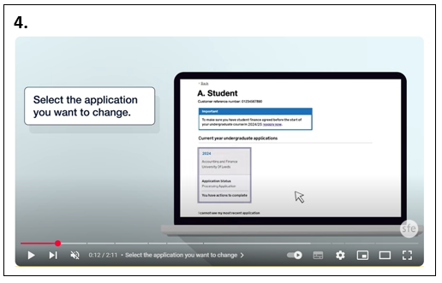

1. You will need to select the application you want to change.

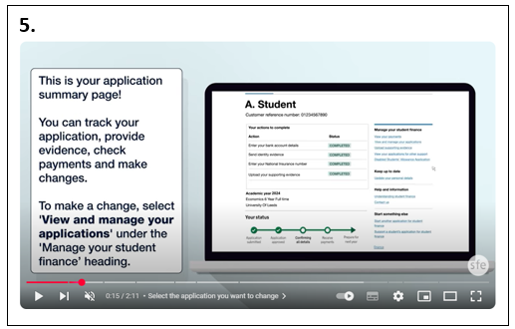

1. You will then arrive at your applications summary page. From this page, you can track your application, provide further evidence, check payments and make any changes.

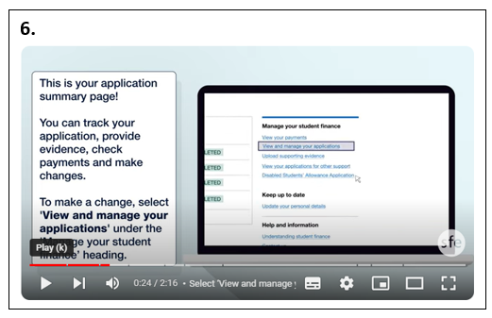

1. To make a change, you will need to select ‘View and manage your applications’ under the ‘Manage your student Finance’ heading.

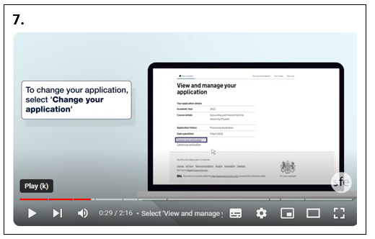

1. You will then need to select ‘Change your application’.

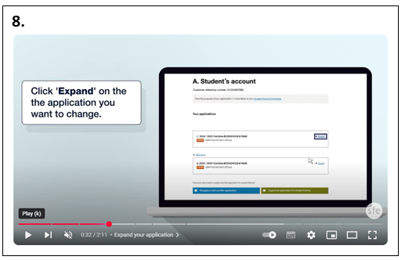

1. Click ‘Expand’ on the application you want to change.

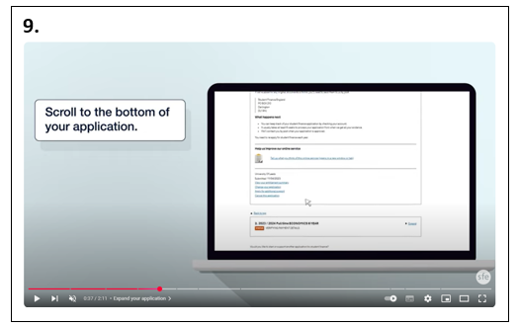

1. You will then need to scroll to the bottom of your application.

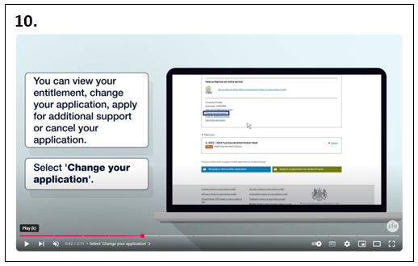

1. You should be able to view your entitlement, change your application, apply for additional support or cancel your application. You will need to select the ‘Change your application’ option.

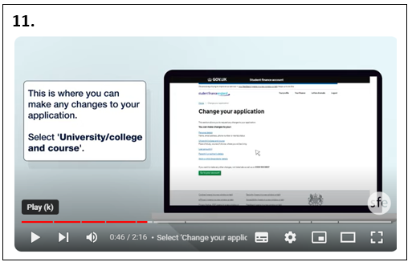

1. This is where you can make any changes to your application. You will need to select the ‘University/college and course’ option.

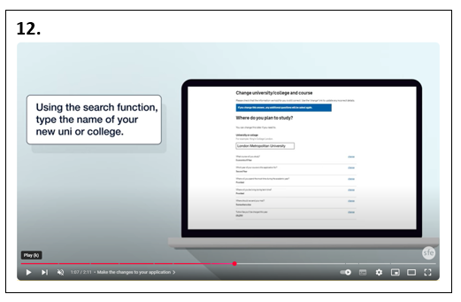

1. Using the search function, you will need to type the name of your new university or college. If it just the course title/name that you need to change, you will need to search for the University of Leeds.

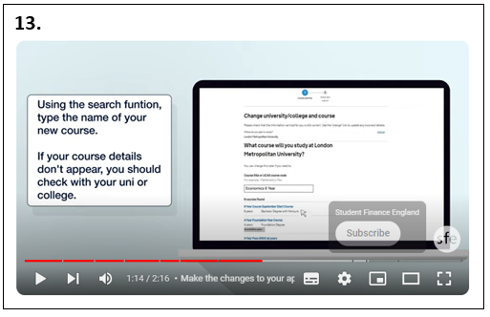

1. Using the search function, type the name of your new course. If your course details don’t appear, you should email [funding@leeds.ac.uk](mailto:funding@leeds.ac.uk).

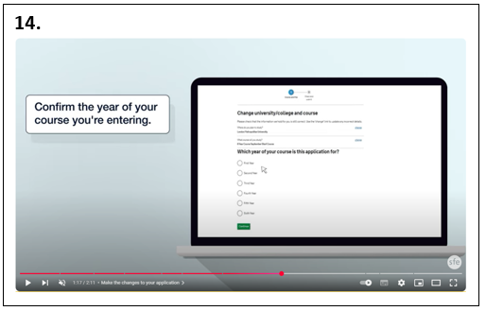

1. Confirm the year of your course you will be entering.

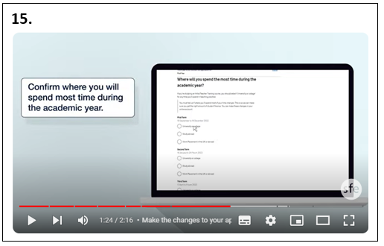

1. Confirm where you will be spending the most time during the academic year. If you will be on a study abroad or work placement year, please check the relevant ‘How to apply for your student loan’ guide on the [University of Leeds study abroad and work placement funding webpages](https://students.leeds.ac.uk/funding-grants-work-placements/doc/apply-student-loan-study-abroad-year) for further support with this.

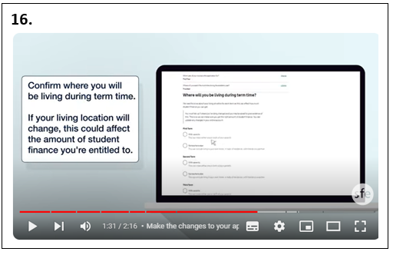

1. Confirm where you will be living during term time. If your living location will change, this could affect the amount of student finance you are entitled to.

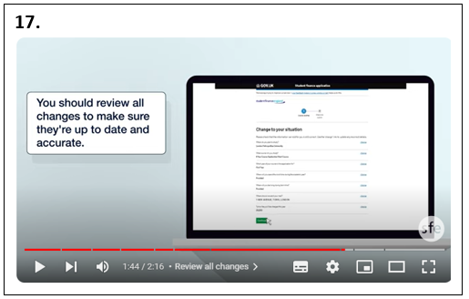

1. You should then review all the changes to make sure they are up to date and accurate.

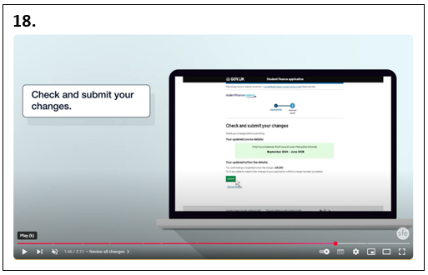

1. Check and submit your changes.

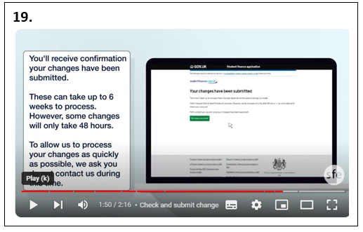

1. You should then receive confirmation your changes have been submitted. These changes can take Student Finance up to 6 weeks to process. However, some changes will only take 48 hours. To allow Student Finance to process your changes as quickly as possible, they request that students do not contact them during this time.

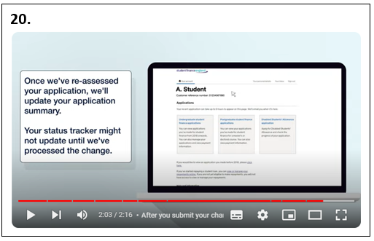

1. Once Student Finance have re-assessed your application, they will update your application summary. Your status tracker might not update until they have processed the change.

**If you have any issues, please contact** [**placement-funding@leeds.ac.uk**](mailto:placement-funding@leeds.ac.uk)**.**