# **How to set up a professional password**

We strongly advise that every student spending a year abroad or on placement sets up a password.

If you have a question or an issue with your student loan, the University can only speak to your loan provider on your behalf if you have set up a Professional Password. It is much easier to do this before you go abroad or on placement, even though you might not need to use it.

You can do this either through your SFE account, or by [calling your student loan provider](https://www.gov.uk/guidance/guidance-on-contacting-the-student-loans-company). This document explains what you need to do for either option.

## Online:

1. Loginto your online account
2. Click on **Undergraduate student finance applications** (or Postgraduate, if appropriate):

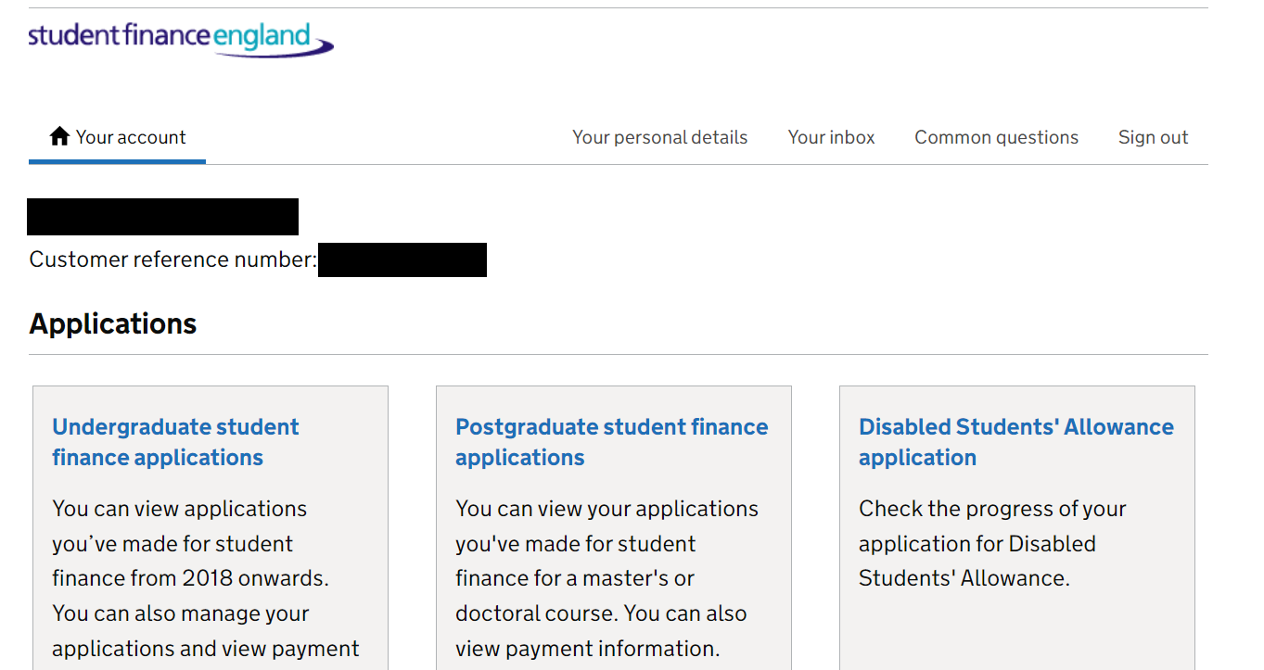

1. Click on your **most recent application:**

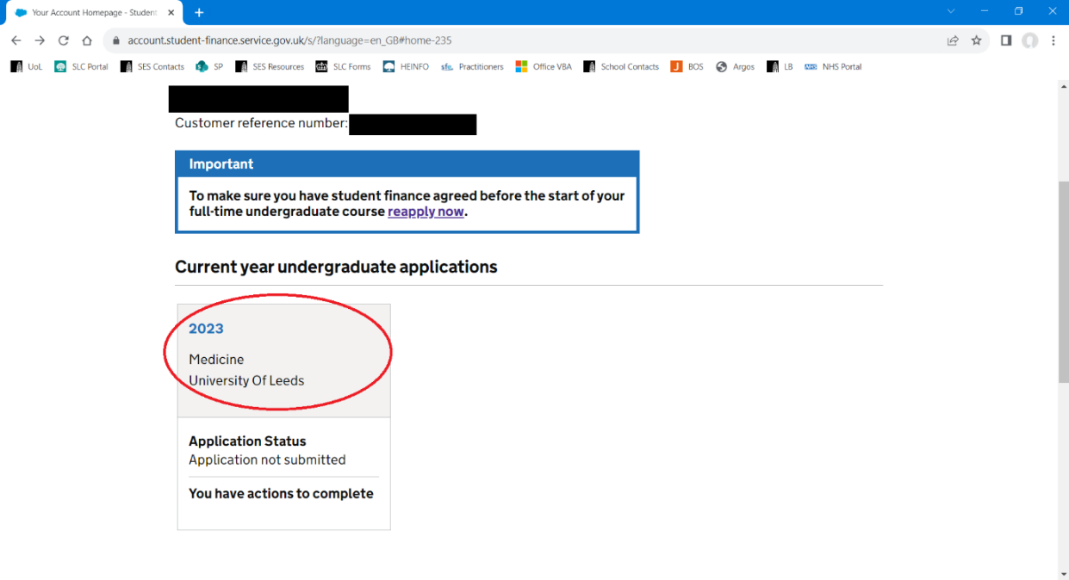

1. Click on **Share your student finance information** in the ‘*Manage your student finance*’ menu:

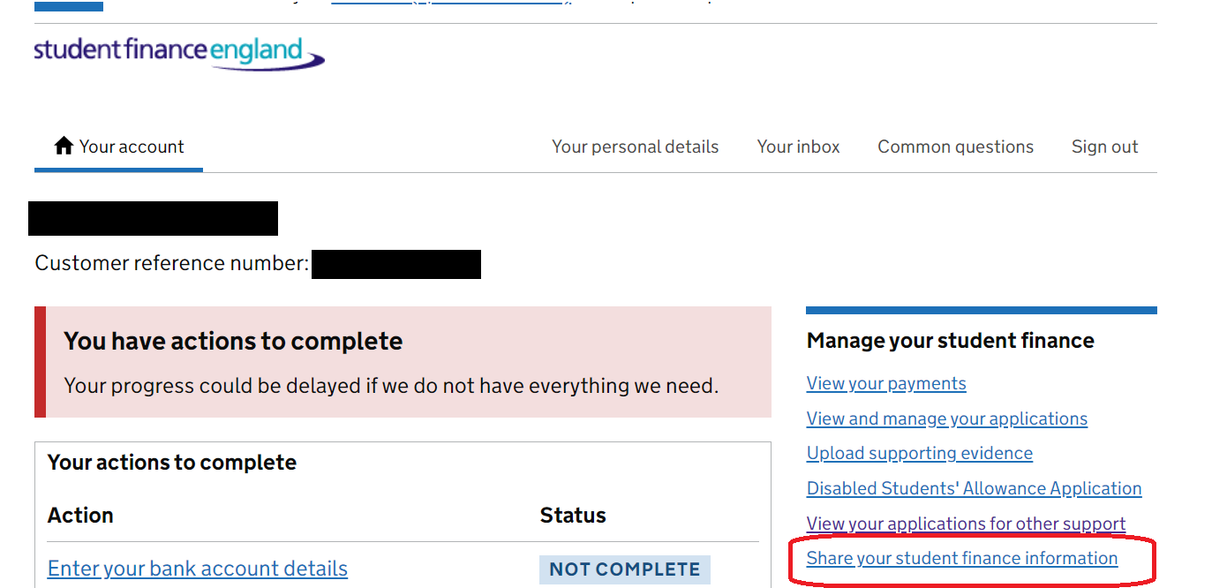

1. Click **Choose a person or organisation:**

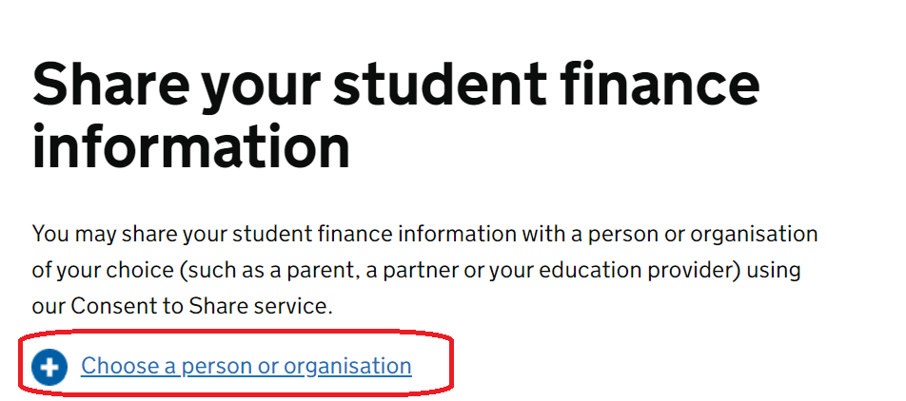

1. Click **Continue:**

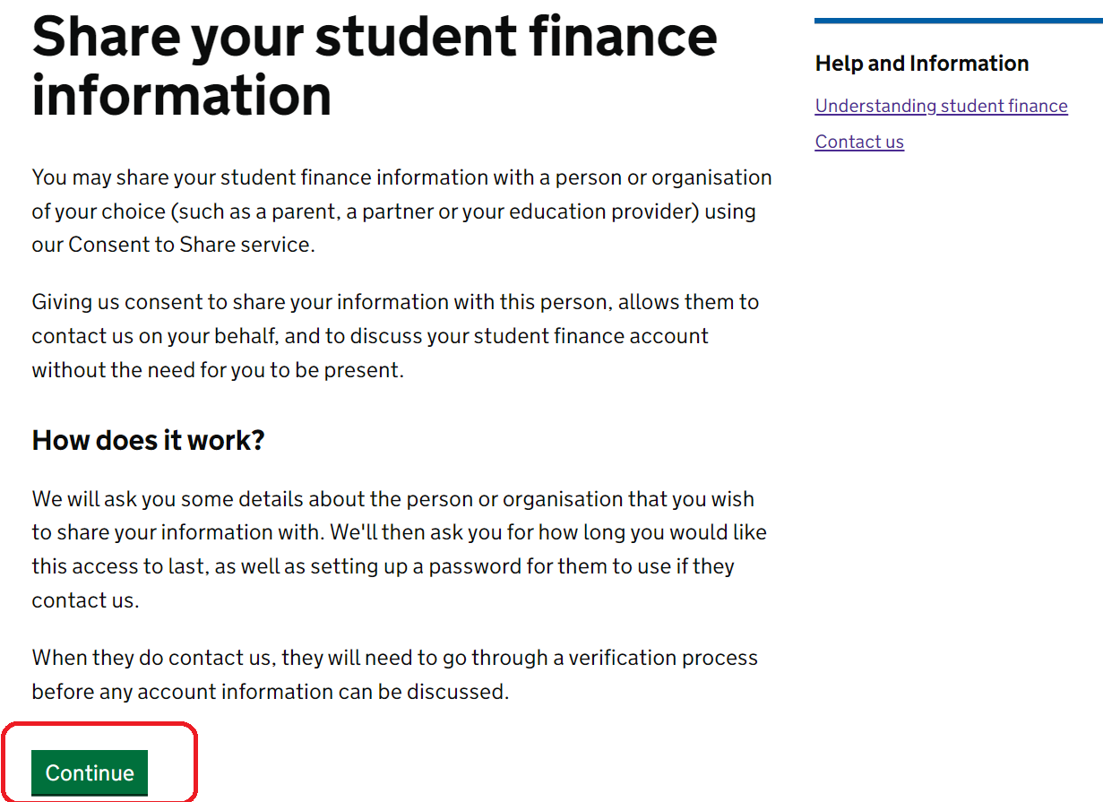

1. Click **Continue** in the section called ‘*What they can’t do*’**:**

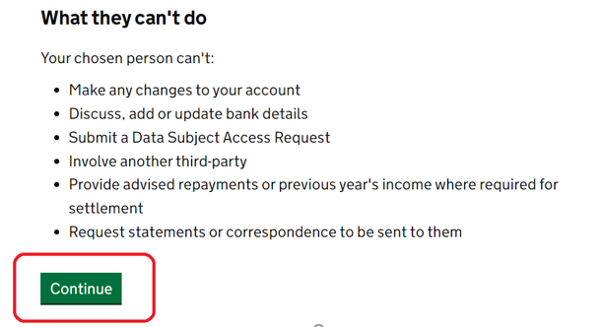

1. Select **An organisation**, then click **Continue**:

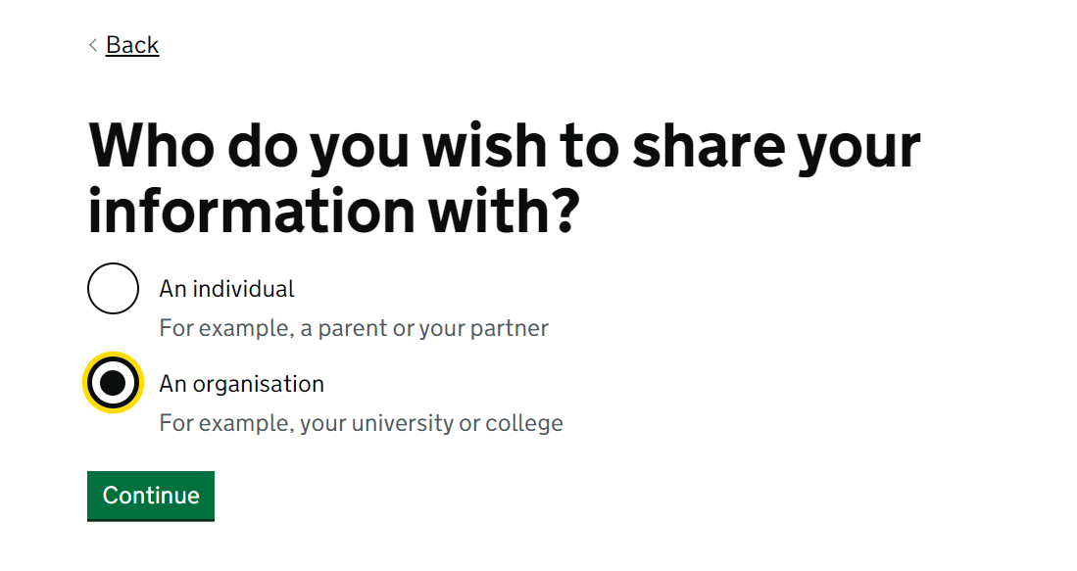

1. Write **The University of Leeds** when asked ‘*Who do you want to share your information with’* then click **Continue**:

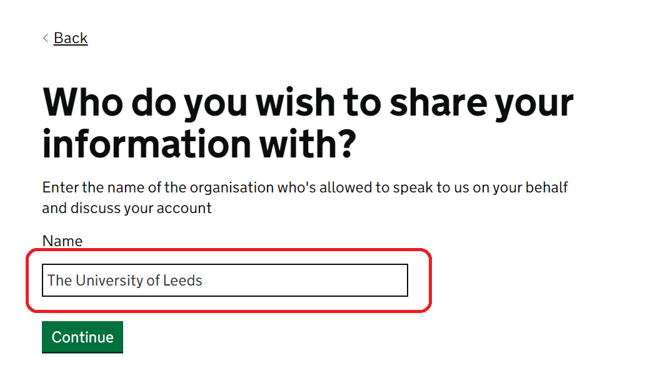

1. Write **Higher Education Provider** when asked ‘*What is their relationship to you?*’ then click **Continue**:

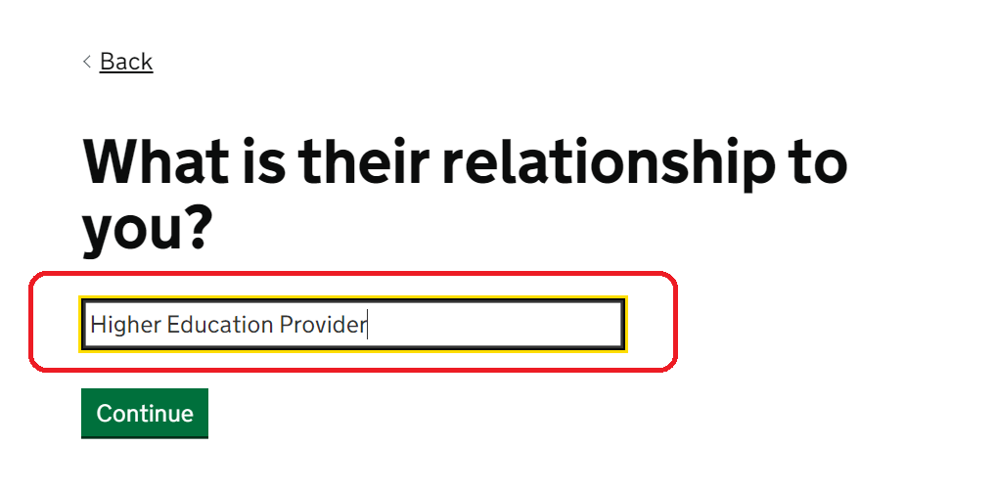

1. Write in your chosen password, then click continue

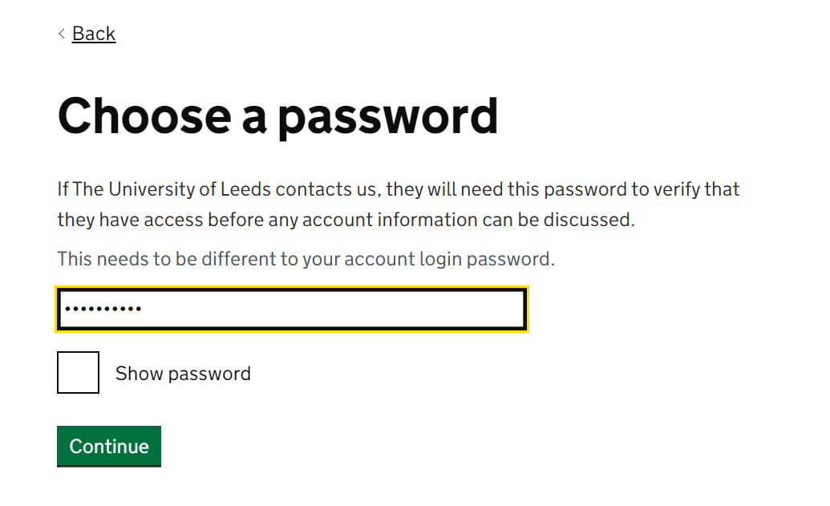

1. Enter the date you want to stop the consent to share to be active. For example, if you wrote 31 in the box labelled Day, 12 in the box labelled Month and 2099 in the box labelled Year, it effectively means that you have given consent for us to share access your student finance information until 31 December 2099

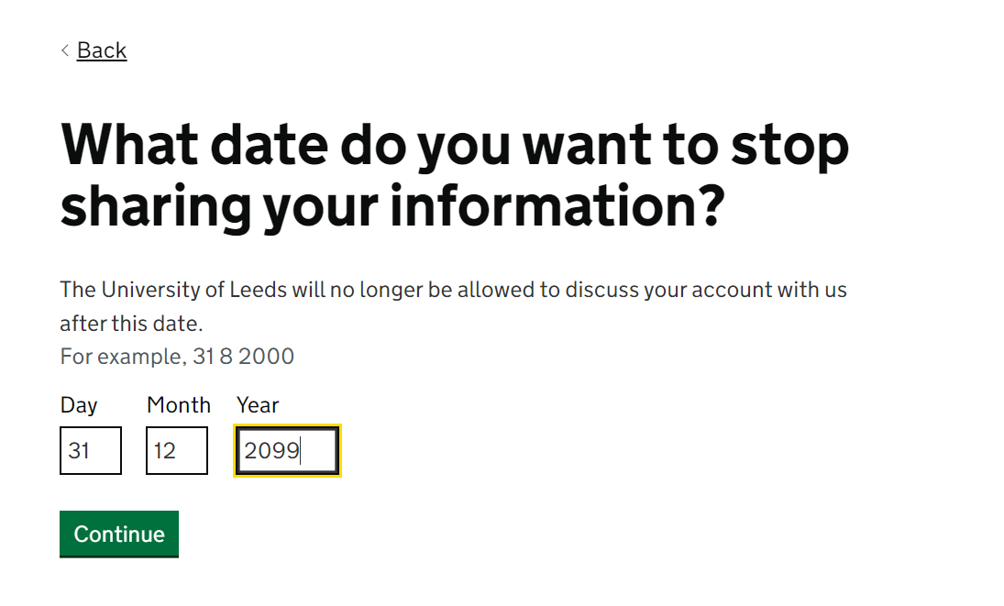

1. You will then be able to review your answers. Make sure that you click **Share my information** in order for the consent to share to be made active.

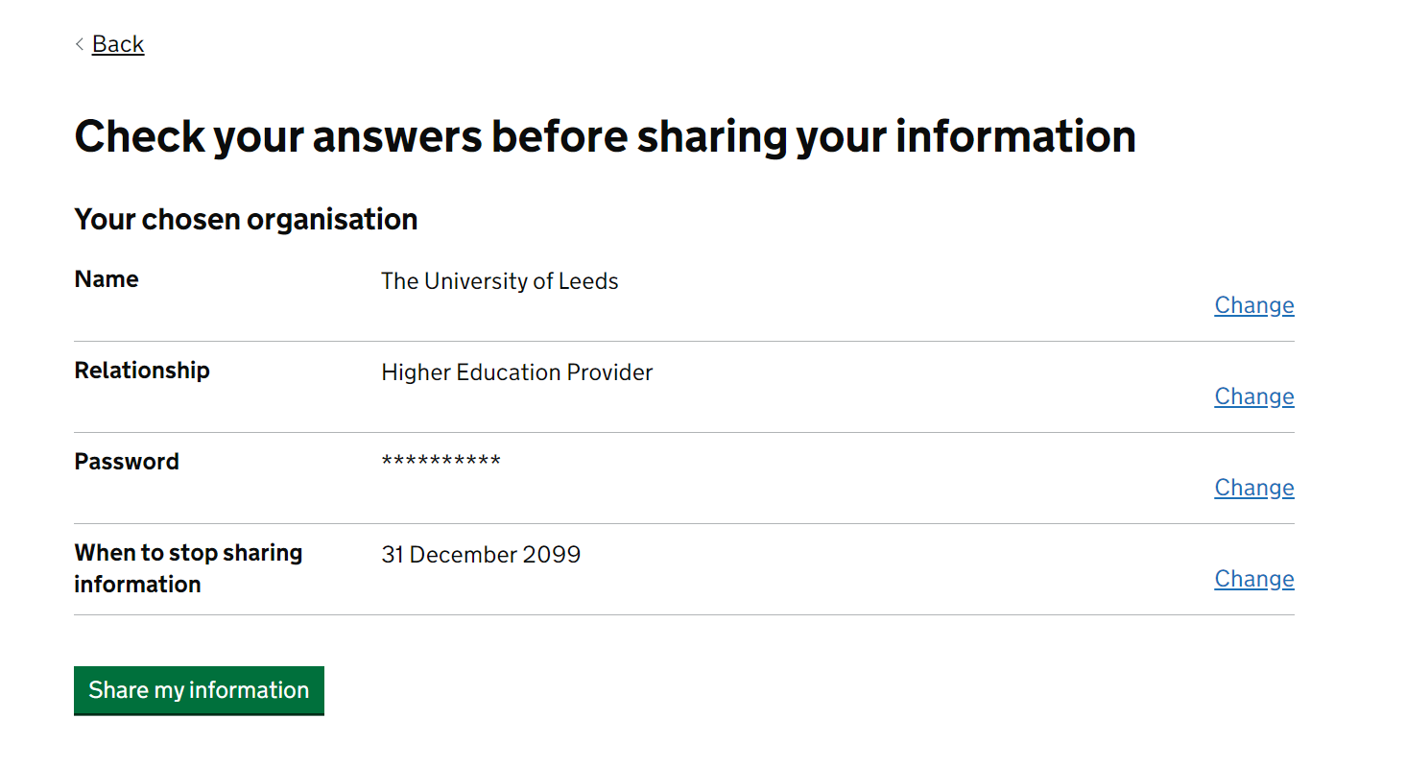

1. You should then see a message that confirms you have given the University of Leeds access to your student finance information.

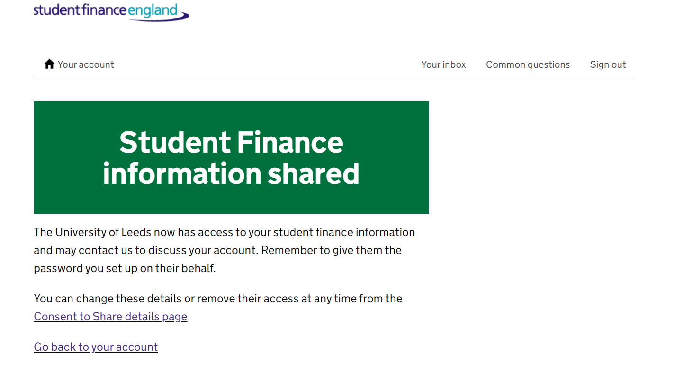

1. Please email the Funding team at [funding@leeds.ac.uk](mailto:funding@leeds.ac.uk) to let us know the password you have chosen. Include your student ID number in the email.

## Calling your loan provider:

* Ask to set up a Professional Password.
* You will be asked who the password is for. You should answer: for the **Higher Education Provider**.
* You will be asked what your relationship is to the university, answer: **My** **HE Provider**
* You can then give your student loan provider a single word password. Please make a note of this and keep it safe.
* This means that if you do experience problems, you can contact [placementfunding@leeds.ac.uk](mailto:placementfunding@leeds.ac.uk) quickly to inform us what the password is, and we'll then be able to speak directly with your loan provider to try to help resolve the issue for you.