Example of a Visa Vignette
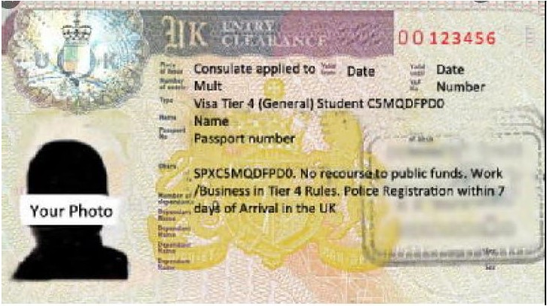
A visa vignette will include the following information:
- Place of Issue. Valid from. Valid Until.
- Number of entries. VAF No.
- Type
- Name
- Passport No. Sex. Date of Birth. Nationality
- Obsrv (Observations)

