# **Example of a passport information page**

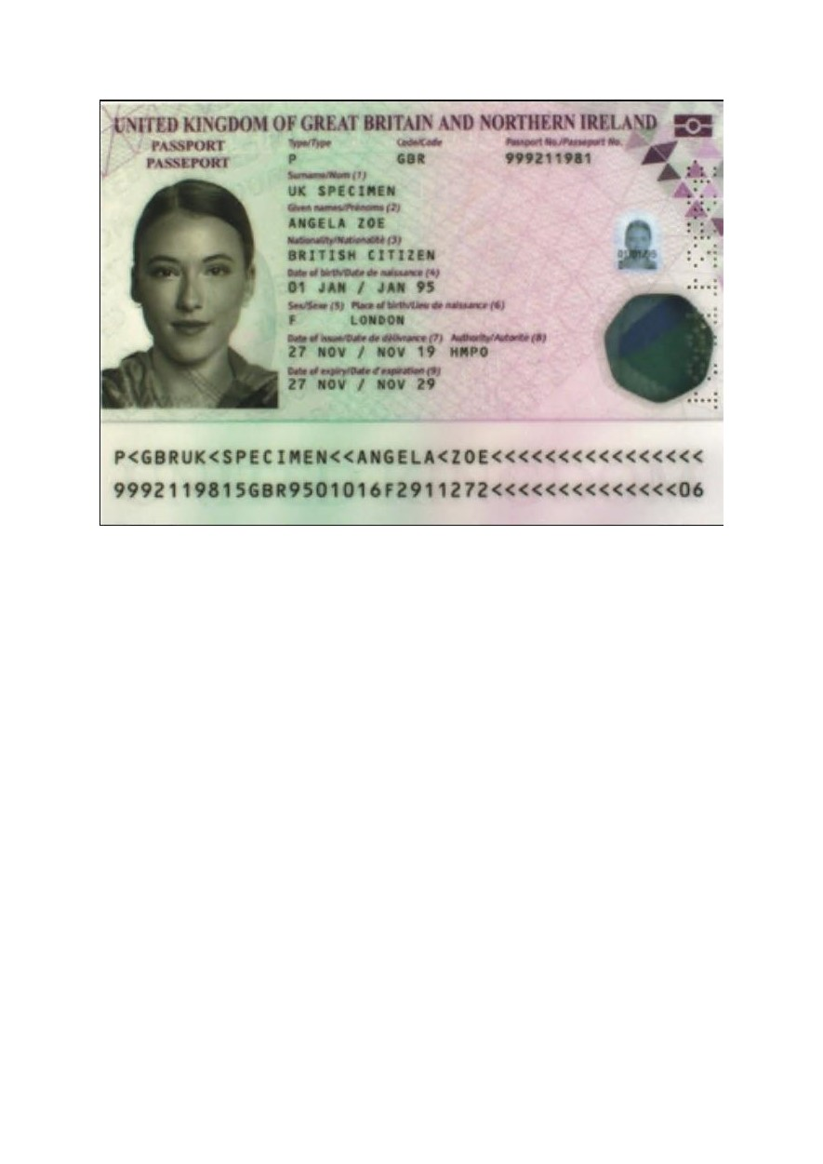

A passport information page will include the following information:

* Passport Photo.
* Type. Code. Passport Number.
* Surname.
* Given Names.
* Nationality.
* Date of Birth.
* Sex. Place of Birth.
* Date of Issue. Authority.
* Date of Expiry.